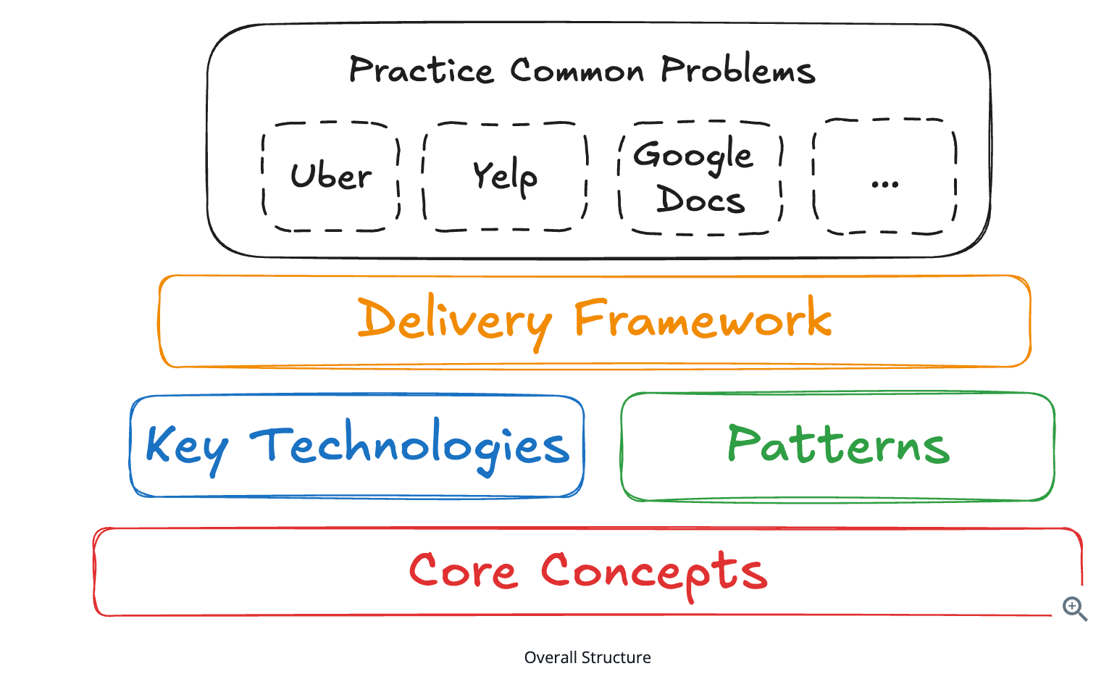  
**Delivery Framework**

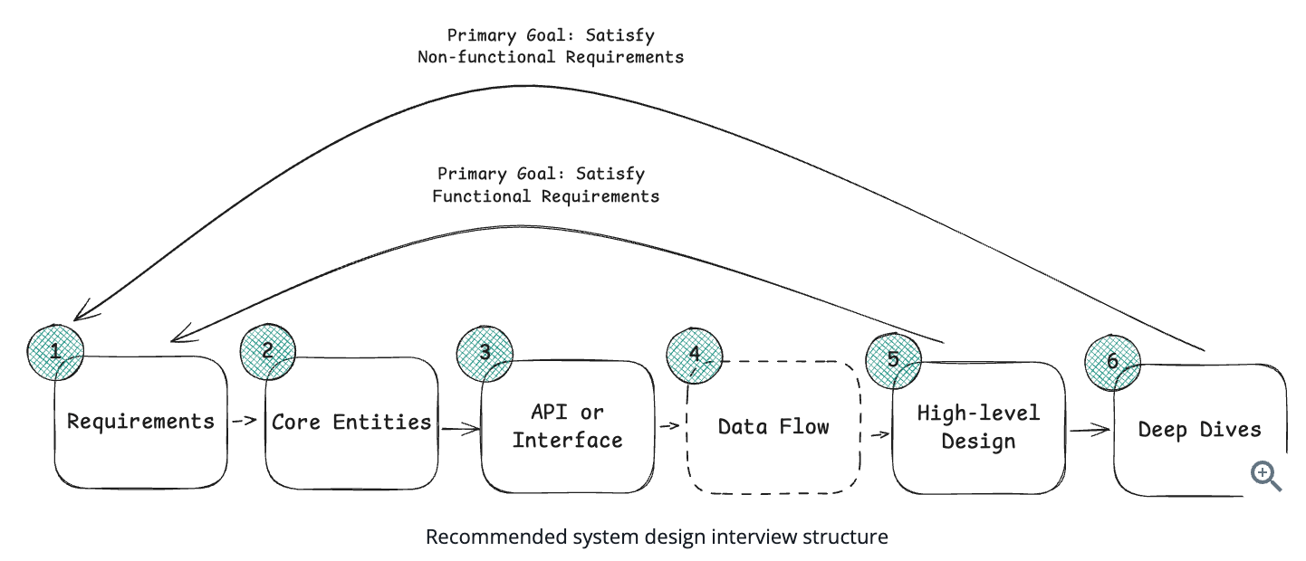

**Requirements (~5 minutes)**

1) Functional Requirements

* Functional requirements are your "Users/Clients should be able to..." statements.
* core features of your system, should be the first thing you discuss with your interviewer.
* Ask targeted questions as if you were talking to a client, customer, or product manager ("does the system need to do X?", "what would happen if Y?") to arrive at a prioritized list of core features.

eg, functional requirements of designing Twitter:

* Users should be able to post tweets
* Users should be able to follow other users
* Users should be able to see tweets from users they follow

A cache meanwhile might have requirements like:

* Clients should be able to insert items
* Clients should be able to set expirations
* Clients should be able to read items

Keep your requirements targeted! The main objective in the remaining part of the interview is to develop a system that meets the requirements you've identified -- so it's crucial to be strategic in your prioritization. Many of these systems have hundreds of features, but it's your job to identify and prioritize the top 3. Having a long list of requirements will hurt you more than it will help you and many top FAANGs directly evaluate you on your ability to focus on what matters.

2) Non-Functional Requirements

- Non-functional requirements are statements about system qualities that are important to users (performance, scale, reliability).

- can be phrased as "The system should be able to"/"The system should be.." statements.  
**-** Always **quantify** when possible (e.g., latency < 200ms)

eg, non-functional requirements of twitter:

* The system should be highly available, prioritizing availability over consistency
* The system should be able to scale to support 100M+ DAU (Daily Active Users)
* The system should be low latency, rendering feeds in under 200ms

It's important that non-functional requirements are put in the context of the system and, where possible, are quantified. For example, "the system should be low latency" is obvious and not very meaningful—nearly all systems should be low latency. "The system should have low latency search, < 500ms," is much more useful as it identifies the part of the system that most needs to be low latency and provides a target.

Identify **top 3–5 most relevant** constraints like:

**CAP Theorem**: Should your system prioritize consistency or availability? Note, partition tolerance is a given in distributed systems.

In a distributed system, **network failures are unavoidable**, so you must assume **partition tolerance** is always required. Because of that, when such a failure happens, the system **cannot guarantee both consistency and availability at the same time**.

**Environment Constraints**: Are there any constraints on the environment in which your system will run? eg, are you running on a mobile device with limited battery life? Running on devices with limited memory/limited bandwidth (eg streaming video on 3G)?

**Scalability**: All systems need to scale, but does this system have unique scaling requirements? For example, does it have bursty traffic at a specific time of day? Are there events, like holidays, that will cause a significant increase in traffic? Also consider the read vs write ratio here. Does your system need to scale reads or writes more?

**Latency**: How quickly does the system need to respond to user requests? Specifically consider any requests that require meaningful computation. eg. low latency search when designing Yelp.

**Durability**: How important is it that the data in your system is not lost? For example, a social network might be able to tolerate some data loss, but a banking system cannot.

**Security**: How secure does the system need to be? Consider data protection, access control, and compliance with regulations.

**Fault Tolerance**: How well does the system need to handle failures? Consider redundancy, failover, and recovery mechanisms.

**Compliance**: Are there legal or regulatory requirements the system needs to meet? Consider industry standards, data protection laws, and other regulations.

3) Capacity Estimations

* Avoid doing estimations **unless they directly affect design decisions**
* Large scale can usually be assumed; generic math (DAU, QPS, storage)adds little value
* Interviewers care more about **design thinking** than arithmetic  
  You can tell the interviewer you’ll **estimate only when needed**
* Estimations matter when they **change the architecture**eg: Top-K system → estimate data size to decide single instance vs sharding
* Focus on **relevant quantities**, not exhaustive calculations  
  Quick estimation skills help reason about **trade-offs**
* Don’t stress about mental math under pressure — it’s common

**Core Entities (~2 minutes)**

- List the core entities of your system. This helps you to define terms, understand the data central to your design, and gives you a foundation to build on.  
- These entities form the basis of your APIs and data model.

- Start with a **simple, first-draft list** rather than a complete schema, because many details and relationships only become clear as the design evolves.

- You can refine and expand the data model later, once the high-level design and state changes are better understood.

For our Twitter example, our core entities are rather simple: User, Tweet, Follow

A couple useful questions to ask yourself to help identify core entities:

* Who are the actors in the system? Are they overlapping?
* What are the nouns or resources necessary to satisfy the functional requirements?

**Naming Matters**

* Choose **clear, meaningful names**
* Entity naming reflects design clarity
* Some interviewers use this to assess design thinking

**API or System Interface (~5 minutes)**

- Before designing the system, define the **API or system interface**, which acts as the contract between the system and its users.

- This contract usually maps to the functional requirements and guides the high-level design to ensure all requirements are met.

You have a quick decision to make here - which API protocol should you use?

**REST (Representational State Transfer)**: Uses HTTP verbs (GET, POST, PUT, DELETE) to perform CRUD operations on resources.

***This should be your default choice for most interviews.***

**GraphQL**: Allows clients to specify exactly what data they want to receive, avoiding over-fetching and under-fetching. Choose this when you have diverse clients with different data needs.

**RPC (Remote Procedure Call)**: Action-oriented protocol (like gRPC) that's faster than REST for service-to-service communication. Use for internal APIs when performance is critical.

eg. For Twitter, we would choose REST and design our endpoints using our core entities as resources. Resources should be plural nouns that represent things in your system:

POST /v1/tweets

body: {

  "text": string

}

GET /v1/tweets/{tweetId} -> Tweet

POST /v1/follows

body: {

  "followee_id": string

}

GET /v1/feed -> Tweet[ ]

Notice how we use plural resource names (tweets, not tweet).

The current user is derived from the authentication token in the request header, not from request bodies or path parameters.

Never rely on sensitive information like user IDs from request bodies when they should come from authentication. Always authenticate requests and derive the current user from the auth token, not from user input.

**Data Flow [Optional]**

For systems with multi-step processing (especially backend or data-processing systems), outline a high-level **sequence of actions** that transform inputs into outputs.

Keep it simple, as a short ordered list. This step helps guide the high-level design later.

If system does not involve complex or sequential processing, it’s fine to skip this step.

For a web crawler, this might look like:

1. Fetch seed URLs
2. Parse HTML
3. Extract URLs
4. Store data
5. Repeat

**High Level Design (~10-15 minutes)**

It consists of drawing boxes and arrows to represent the different components of your system and how they interact. Components are basic building blocks like servers, databases, caches, etc.

[Key Technologies](https://www.hellointerview.com/learn/system-design/in-a-hurry/key-technologies) section will give u good sense of most common components you'll need to know.

Don’t overthink or add complexity too early. Start with a basic design, often by walking through API endpoints one by one, and layer in additional components later to address non-functional requirements.

If you notice areas where caches or queues may help, note them and move on.

While drawing, **talk through your reasoning**, explain data flow, and describe how system state changes per request.

Begin documenting only the **relevant data fields** near persistence layers, avoiding obvious or unnecessary schema details.

Eg. Twitter, here is how you might build up your design, one endpoint at a time:

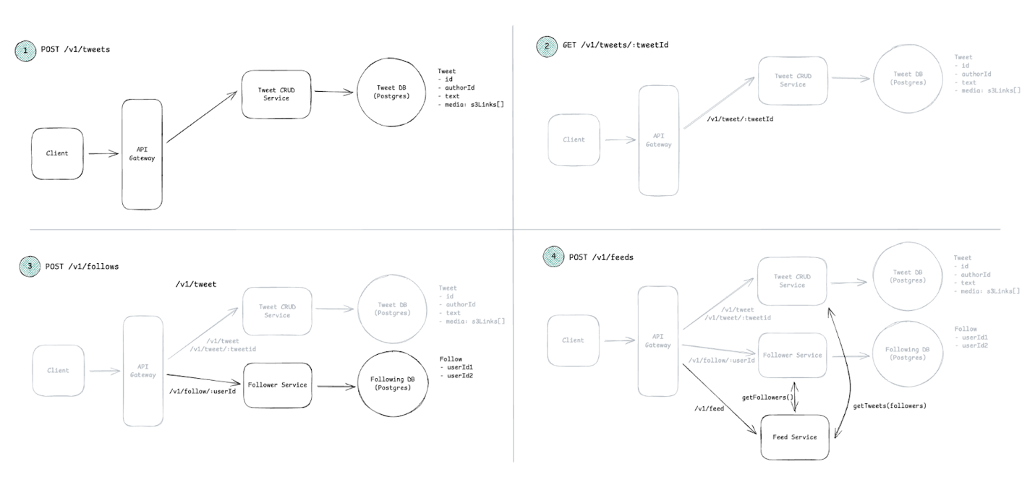

**Deep Dives (~10 minutes)**

* Use this phase to **refine and strengthen** the high-level design
* Focus on:
  + Meeting **non-functional requirements**
  + Handling **edge cases**
  + Identifying and fixing **bottlenecks**
  + Improving design based on **interviewer feedback**
* Expect to iterate on known inefficiencies
* Seniority matters:
  + Junior: interviewer leads improvements
  + Senior: candidate proactively leads deep dives
* Discuss scaling, caching, sharding, and performance trade-offs
* Use concrete examples (e.g., feed generation strategies)
* Update the design as you reason through changes
* Leave space for interviewer questions to show collaboration

**Core Concepts**

**Networking Essentials**

At a basic level, you need to understand how services talk to each other and what happens when those connections fail or get slow.

The most important decision you'll make is choosing your communication protocol. For most systems, you'll default to HTTP over TCP. It's well-understood, works everywhere, and handles 90% of use cases. Your interviewer will expect this unless you have a specific reason to use something else.

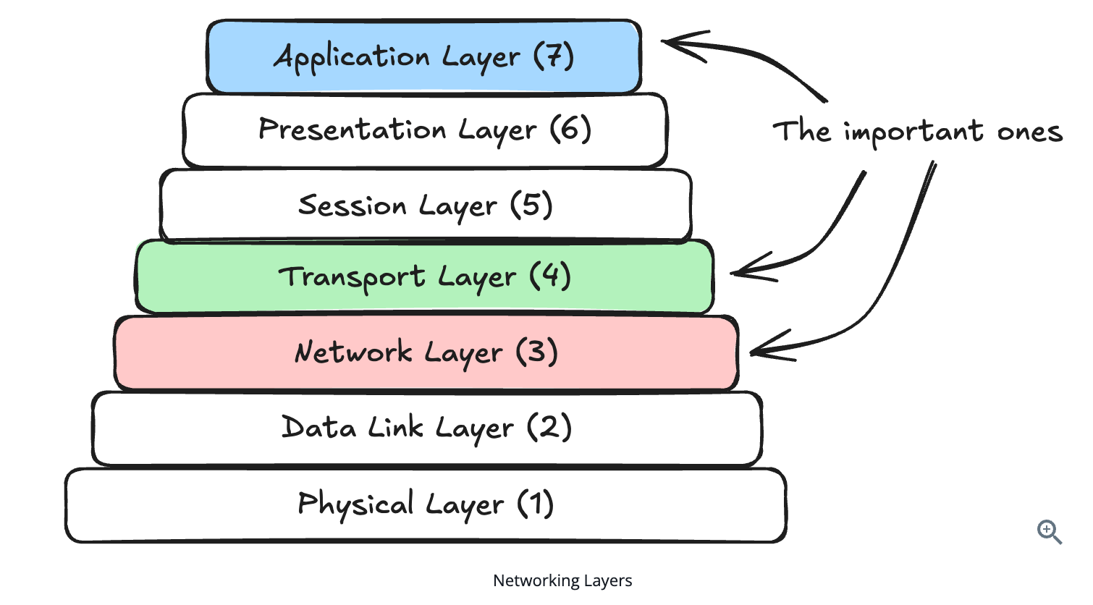

**API Design**  
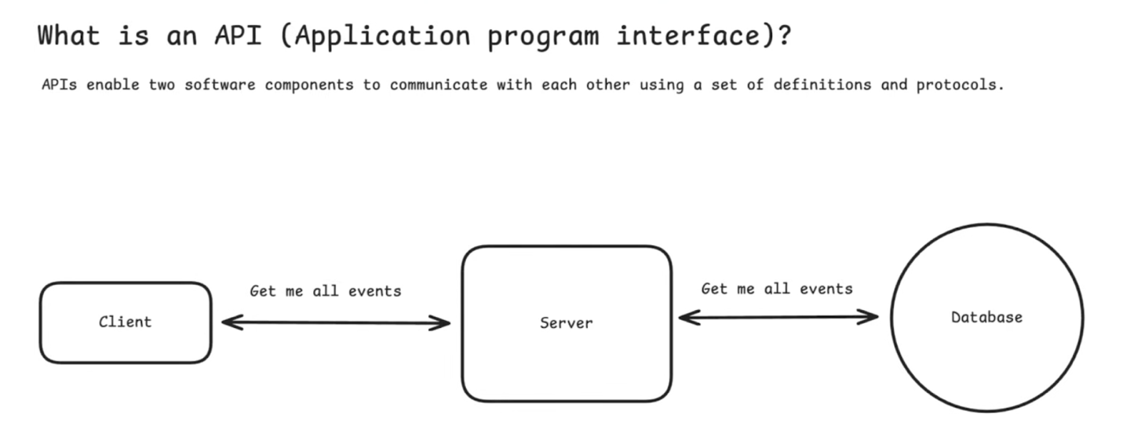

**External API service:** Client - Server [REST, GraphQL]

**Internal API service:** Server - Server [RPC Remote Procedure Calls]

**Real time protocols:** WebSocket, Server-Sent events, WebRTC

- Create open continuous connections where you can stream data between the client and server e.g. chat app

For real-time features like notifications, chat, or live updates, you'll need different protocols like WebSockets or Server-Sent Events. These aren't traditional APIs - they're persistent connections.

**API Types:**

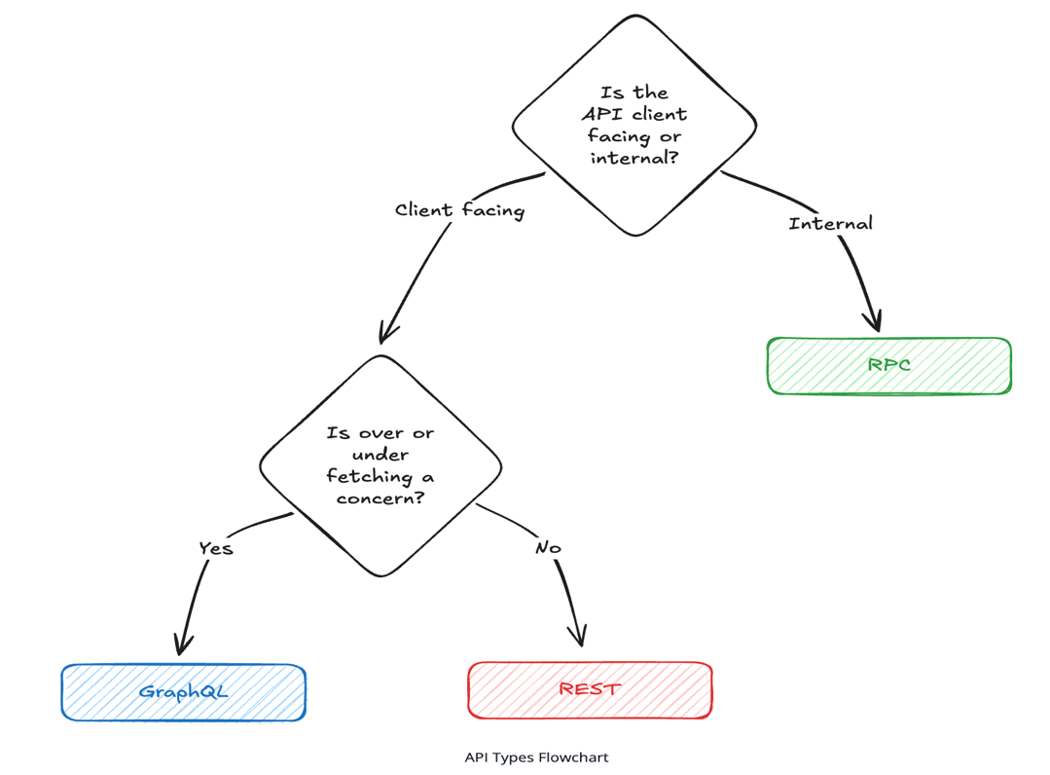

**1. REST (Representational State Transfer)**

- REST uses standard HTTP methods (GET, POST, PUT, DELETE) to manipulate resources identified by URLs.

- For standard CRUD operations in web and mobile applications, REST maps naturally to your database operations and HTTP semantics, making it the go-to protocol for most web services.

**2. GraphQL**

- Unlike REST's fixed endpoints, GraphQL uses a single endpoint with a query language that lets clients specify exactly what data they need.

- This avoids over-fetching and under-fetching common in REST and is especially useful when different clients (e.g., mobile vs web) require different data shapes.

- If your interviewer mentions "flexible data fetching" or talks about avoiding over-fetching and under-fetching, they're signaling you to consider GraphQL.

**3. RPC (Remote Procedure Call)**

- RPC (eg gRPC) is ideal for **high-performance, internal service-to-service communication**.

- It’s action-oriented, faster than REST due to binary serialization and HTTP/2, and fits naturally for operations like permission checks.

- If the interviewer specifically mentions **microservices or internal APIs**, consider RPC for those high-performance connections. Use RPC when performance is critical.

**REST**

**Resource Modeling**

The foundation of good REST API design is identifying your resources correctly, resources are just your [core entities](https://www.hellointerview.com/learn/system-design/in-a-hurry/delivery#core-entities-2-minutes).

GET /events                    # Get all events

GET /events/{id}               # Get a specific event

GET /venues/{id}               # Get a specific venue

GET /events/{id}/tickets       # Get available tickets for an event

POST /events/{id}/bookings     # Create a new booking for an event

GET /bookings/{id}                  # Get a specific booking

Importantly, REST resources should represent *things* in your system, not *actions*. Instead of thinking about what users can do (like "book" or "purchase"), think about what exists in your system (events, venues, tickets, bookings).

Resources should always be plural nouns, i.e., bookings, events, tickets, etc. (NOT verbs)

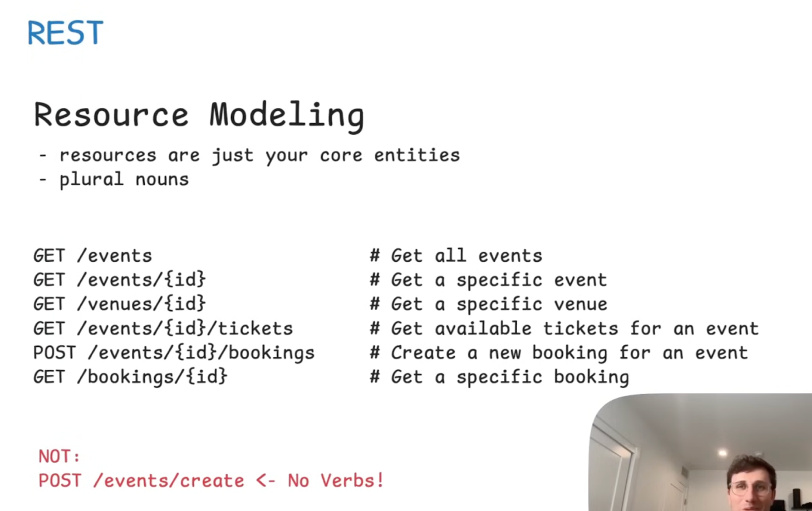

When handling relationships between resources, you have two main approaches.

- You can nest resources when there's a clear parent-child relationship, like /events/{id}/tickets for all tickets belonging to specific event.

- Value is required. **[PATH parameter]**

- You can keep resources flat and use query parameters for filtering, like /tickets?event_id=123.

- when the filter is optional **[Query Parameter]**

The key difference is whether the relationship is required or optional.

**HTTP Methods**

Once you've identified your resources, you need to decide how clients interact with them. HTTP provides a set of methods (**verbs**) that map naturally to common operations, and understanding when to use each one is crucial for interviews.

**1. GET :** retrieving data without changing anything.

**2. POST :** creates new resources.

POST is neither safe nor idempotent. In other words, calling it multiple times creates multiple bookings.

**3. PUT :** replaces an entire resource with what you send.

PUT is idempotent, so sending same data multiple times results in the same final state.

**4. PATCH :** updates part of a resource.

user changes just their email, PATCH to /users/{id} with only the email field.

**5. DELETE :** removes a resource.

It's idempotent - deleting an already-deleted resource should return the same result.

Operations that can be safely repeated without changing the outcome (GET, PUT, PATCH, DELETE) are **idempotent**. This matters when networks fail and clients retry requests, you don't want duplicate bookings from a retry.

**Passing Data to APIs**

API endpoints need input to tell the server what to do. This can be which resources to fetch, what data to update in the database, or how to filter results.

Understanding where to put different types of input is crucial for designing clean, intuitive APIs.

You have three main options for passing data to your REST API, and each serves a different purpose.

**Path parameters** identify which specific resource you're working with. When you want to get event details, you put the event ID in the path: /events/123. The ID is part of the URL structure itself, making it clear that you're asking for a specific event, not a collection of events. Use path parameters when the value is required to identify the resource - without it, the request doesn't make sense.

**Query parameters** filter, sort, or modify how you retrieve resources. When you want to search for events in a specific city or date range, you use query parameters: /events?city=NYC&date=2024-01-01.

These are optional - you could ask for all events without any filters, or apply multiple filters together. Query parameters work well for pagination too: /events?page=2&limit=20. Note that the first option is separated via a ? and all subsequent parameters are separated by &.

**Request body** contains the actual data you're sending to create or update resources. When a user books tickets, you POST to /events/{id}/bookings with the booking details in the request body. Things like how many tickets, seating preferences, and so on. The request body is where you put complex data structures and anything that might be too large or sensitive for a URL.

Each type of input serves a different role in the API's contract.

Path parameters are structural, they determine which endpoint you're hitting. The event ID (123) is in the path because you need to specify which event you're booking.

Query parameters are modifiers, they change how the endpoint behaves. The notification preference is a query parameter because it's optional behavior.

Request body is the payload, it's the data you're actually working with. The actual booking details go in the request body because they're the core data you're creating.

Here's a practical example. If you're building a booking system and a user wants to book VIP tickets for a specific event, you'd structure it like this:

POST /events/123/bookings?notify=true

{

  "tickets": [

    {"section": "VIP", "quantity": 2},

    {"section": "General", "quantity": 1}

  ],

  "payment_method": "credit_card"

}

**Returning Data**

An API response is made up of two parts:

* The status code, which indicates whether the request was successful or not.
* The response body, which contains the data you're returning to the client (typically JSON)

**Status Codes**

200: success,

201 : created resources

400 : bad requests,

401 : authentication required

404 : not found

Success (2xx), Client errors (4xx) and Server errors (5xx)

**GraphQL**

GraphQL was created at Facebook in 2012 to address limitations of REST when different clients (web vs mobile) need different data. REST endpoints return fixed response structures, which forces teams to either create many specialized endpoints or return excessive data. Both approaches slow development and cause inefficiencies.

[You can create multiple endpoints for different use cases, leading to endpoint proliferation and maintenance headaches. Or you can make your endpoints return everything any client might need, leading to over-fetching where mobile clients download megabytes of data they don't use.]

GraphQL consolidates resource endpoints into a single endpoint that accepts queries describing exactly what data you want. The client specifies the shape of the response, and the server returns data in that exact format. The client specifies the shape of the response, and the server returns data in that exact format.

**How GraphQL Works**

Here's a simple example using our Ticketmaster scenario.Instead of separate REST endpoints for events, venues, and tickets, you'd have a single GraphQL endpoint

query {

  event(id: "123") {

    name

    date

    venue {

      name

      address

    }

    tickets {

      section

      price

      available

    }}}

The server returns exactly what you asked for, nothing more, nothing less.

**When to Use GraphQL in Interviews**

GraphQL is the right choice when you have diverse clients with different data needs. If your interviewer mentions scenarios like "the mobile app needs different data than the web app" or asks about "avoiding over-fetching and under-fetching," they're likely looking for you to bring up GraphQL.

It's also a good choice when frontend teams need to iterate quickly without backend changes. With REST, adding a new field to a mobile screen often requires backend changes and API deployments. With GraphQL, the frontend team can request additional fields as long as they exist in the schema.

However, GraphQL adds complexity. You need to implement query parsing, schema validation, and often sophisticated caching strategies.

**GraphQL Schema Design**

If you do choose GraphQL, you'll need to think differently about design. Instead of REST's resource endpoints, you design a schema that defines your data types and their relationships.

For our Ticketmaster example, you'd start by modeling your core entities as GraphQL types:

type Event {

  id: ID!

  name: String!

  date: DateTime!

  venue: Venue!

  tickets: [Ticket!]!

}

type Venue {

  id: ID!

  name: String!

  address: String!

}

type Query {

  event(id: ID!): Event

  events(limit: Int, after: String): [Event!]!

}

The key difference from REST is that you define relationships directly in the schema. An Event has a Venue, and clients can traverse that relationship in a single query.

But this flexibility creates the **N+1 problem**, the biggest GraphQL gotcha. When a client queries events with their venues, you might execute one query for events, then N separate queries for each venue. With 100 events, that's 101 database queries instead of 2. The solution is batching/dataloader patterns that group related queries together, but it adds complexity you don't have with REST.

GraphQL also handles authorization differently. Instead of securing entire endpoints like REST, you secure individual fields. A user might see an event's name and date but not the venue data. You can control this at the field level in your schema resolvers.

**RPC**

RPC (Remote Procedure Call) is a protocol that allows a client to call a procedure on a server and wait for a response without the client having to understand the underlying network details.

It's faster than HTTP for service communication, especially when you need high performance and low latency.

**How RPC Works**

Unlike REST's resource-oriented approach, RPC is action-oriented. You're essentially calling functions across a network as if they were local functions in your codebase. Here's how the same Ticketmaster operations might look with RPC:

// Instead of GET /events/123

getEvent(eventId: "123")

// Instead of POST /events/123/bookings

createBooking(eventId: "123", userId: "456", tickets: [...])

// Instead of GET /events/123/tickets

getAvailableTickets(eventId: "123", section: "VIP")

The most popular RPC protocol today is [gRPC](https://grpc.io/), which uses Protocol Buffers for serialization and HTTP/2 for transport. This combo is much faster than REST's JSON-over-HTTP approach, especially for service-to-service communication.

Another notable RPC framework is [Apache Thrift](https://thrift.apache.org/), originally developed at Facebook and now open source, which supports multiple programming languages and serialization formats.

**Protocol Buffers and Type Safety**

gRPC uses Protocol Buffers (protobuf) to define service contracts. You write a .proto file that describes your service methods and data structures:

service TicketService {

  rpc GetEvent(GetEventRequest) returns (Event);

  rpc CreateBooking(CreateBookingRequest) returns (Booking);

  rpc GetAvailableTickets(GetTicketsRequest) returns (TicketList);

}

message GetEventRequest {

  string event_id = 1;

}

message Event {

  string id = 1;

  string name = 2;

  int64 date = 3;

  Venue venue = 4;

}

From this single definition, gRPC generates client and server code in multiple programming languages. This means your Go backend service and your Java payment service can communicate with compile-time type safety, catching mismatches before deployment.

**When to Use RPC in Interviews**

RPC shines in microservice architectures where services need to communicate frequently and efficiently. If your interviewer mentions internal service communication, high-performance requirements, or polyglot environments (different services in different languages), RPC is likely a good choice.

Consider RPC when:

* **Performance is critical**: Binary serialization and HTTP/2 make RPC significantly faster than JSON REST
* **Type safety matters**: Generated client code prevents many runtime errors
* **Service-to-service communication**: Internal APIs between your own services don't need REST's resource semantics
* **Streaming is needed**: gRPC supports bidirectional streaming for real-time features

For our Ticketmaster example, you might use REST APIs for your public endpoints that mobile apps and web clients consume, but use gRPC for internal communication between your booking service, payment service, and inventory service.

Unless explicitly asked, you won't typically outline your internal APIs during the [API step](https://www.hellointerview.com/learn/system-design/in-a-hurry/delivery#api-or-system-interface-5-minutes) of the interview. Instead, focus on just the user facing APIs here. At most, you'll call out that internal services communicate over RPC during your high-level design.

**Common API Patterns**

Regardless of whether you choose REST, GraphQL, or RPC, there are some patterns that apply across all API types.

**Pagination**

When you're dealing with large datasets, you can't return everything at once. Imagine an API that returns all events ever created, that could be millions of records which would be many gigabytes of data.

Instead, you need pagination to break large result sets into manageable chunks.

**Offset-based Pagination**

- simplest approach and used by most websites

- You specify how many records to skip and how many to return: /events?offset=20&limit=10 gets records 21-30.

- This is intuitive and easy to implement, but it has problems with large datasets. If someone adds a new event while you're paginating through results, you might see duplicates or miss records as the data shifts.

**Cursor-based Pagination**  
- Cursor-based pagination solves this by using a pointer to a specific record instead of counting from the beginning.

First request: /events?limit=10

Response includes the events plus a cursor pointing to the last record:

{

  "events": [...],

  "next_cursor": "cmd9atj3p000007ky19w1dpy2"

}

Next request: /events?cursor=cmd9atj3p000007ky19w1dpy2&limit=10

The cursor is typically an encoded reference to a specific record (like an ID or timestamp). This is more stable because it's not affected by new records being added, but it's harder to implement features like "jump to page 5."

For interviews, offset-based pagination is usually fine unless you're dealing with real-time data or the interviewer specifically asks about high-volume scenarios. Most interviewers care more about whether you remembered to include pagination than which specific approach you choose.

**Versioning Strategies**

APIs evolve over time, and you need a strategy for handling changes without breaking existing clients. This is particularly important for public APIs where you can't control when clients update their code.   
The most common and interview-friendly approach is URL versioning, where you include the version number in the path (e.g., /v1/events, /v2/events) which is explicit, easy to understand, and simple to implement (since different versions can be routed to separate code paths.)

Another option is **header versioning**, where the version is specified in an HTTP header such as Accept-Version: v2 or API-Version: 2.

While this keeps URLs clean and aligns better with HTTP standards, it is less visible to developers and harder to test, particularly in browsers.

For interviews, URL versioning is usually the safer choice because it's more widely understood and easier to explain quickly. Unless the interviewer specifically asks about header versioning, stick with the URL approach.

You'll see that in our breakdowns we don't even include versioning in the API design. This is more a product of it just not being important to most interviewers rather than a statement that it's not important in practice (it is).

**Security Considerations**

**Authentication and Authorization**

The first question your API needs to answer is: "Who is making this request, and are they allowed to do what they're asking?

**Authentication** verifies identity - proving the user is who they claim to be. **Authorization** verifies permissions - checking if that authenticated user is allowed to perform the specific action they're requesting.

For our Ticketmaster example,

authentication might verify that the request comes from user "john@example.com", while authorization checks if John is allowed to cancel the specific booking he's trying to cancel (he should only be able to cancel his own bookings, not everyone's).

**API Keys vs JWT Tokens**

When designing authentication for your API, you'll typically choose between two main approaches depending on who will be using your API and how they'll access it.

For most (but not all), interviews, authentication and authorization are not a focus. My advice would be to call out which endpoints require the user be authenticated and say that you'd rely on a [JWT](https://jwt.io/) or store the user's session in a database to authenticate the user.

**API Keys**

API keys are long, randomly generated strings that act like **passwords for applications**(not humans.)

Clients include the API key in the **Authorization header** with each request.  
The server uses the key to **identify which application** is making the request.

**How API keys work**

* Generate a **unique API key per client** (for example: sk_live_abc123def456...).
* Store the key in your database along with **permissions and rate limits**.
* On every request, **verify the key** by looking it up.
* Authentication is based on the application, not an individual user.

**Best use cases**

* **Server-to-server communication** where you control both sides.
* Internal service calls (for example, booking service calling payment service).
* Exposing APIs to **3rd-party developers** who need programmatic access.

API keys are long, randomly generated strings that act like passwords for applications rather than humans. When a client makes a request, they include their API key in the Authorization header, and your server looks up that key to identify which application is making the request.

Here's how they work: you generate a unique API key for each client (like sk_live_abc123def456...), store it in your database along with any permissions or rate limits for that client, and then verify each incoming request by looking up the key. They're perfect for server-to-server communication where you control both sides. When your booking service needs to call your payment service, an API key is straightforward and effective. They also make sense when you're exposing your endpoints to 3rd party developers who need programmatic access to your system.

If you're building a user-facing product with user-facing APIs, API keys are almost never the right choice. Users shouldn't be managing long cryptographic strings, and API keys don't expire or carry user context the way user sessions need to.

**Example** GET /events

Authorization: Bearer sk_live_abc123...

**JWT (JSON Web Tokens)**

JWT tokens, on the other hand, encode user information directly into the token itself rather than storing session state on your server. When a user logs in successfully, your server creates a JWT containing their user ID, permissions, and an expiration time, then signs the entire token with a secret key.

Conveniently, when that JWT comes back with future requests, you can verify it's authentic by checking the signature, and you can read the user information directly from the token without any database lookups. The token itself carries all the context you need to authorize the request.

JWTs work particularly well for distributed systems because any service that knows your signing secret can validate tokens independently. If your mobile app sends a JWT to your API gateway, the gateway can verify the user's identity and forward the request to your booking service with confidence.

// JWT payload

{ "user_id": "123",

  "email": "john@example.com",

  "role": "customer",

  "exp": 1640995200}

Use API keys for internal service communication and external developer access. Use JWT tokens for user sessions in web and mobile applications. JWT tokens can be stateless (no database lookup required) and can carry user context, making them ideal for user-facing applications.

**Role-Based Access Control (RBAC)**

Real systems have different types of users with different permissions. In our Ticketmaster system, customers can book tickets and view their bookings, venue managers can create events and view sales reports, and system admins can access everything.

RBAC assigns roles to users and permissions to roles:

Roles:

- customer: can book tickets, view own bookings

- venue_manager: can create events, view sales for their venues

- admin: can access everything

User: john@example.com → Role: customer

User: manager@venue.com → Role: venue_manager

In your API design, you'd check both authentication and authorization:

GET /bookings/{id}

1. Is the user authenticated? (valid JWT token)

2. Is the user authorized? (owns this booking OR is admin)

At most, in an interview you'd just mention which endpoints can be accessed by which roles, though more times than not this distinction is not relevant.

**Rate Limiting and Throttling**

**Rate limiting** prevents abuse by restricting how many requests a client can make in a given time period. This protects your system from both malicious attacks and accidental overuse.

Common strategies include:

* **Per-user limits**: 1000 requests per hour per authenticated user
* **Per-IP limits**: 100 requests per hour for unauthenticated requests
* **Endpoint-specific limits**: 10 booking attempts per minute to prevent ticket scalping

You typically implement rate limiting at the API gateway level or using middleware in your application. When limits are exceeded, return a 429 Too Many Requests status code.

In interviews, mentioning rate limiting shows you understand production concerns, but don't spend time designing the specific algorithms unless asked. A simple "we'll implement rate limiting to prevent abuse" is usually sufficient.

**Conclusion**

API design in system design interviews is about demonstrating solid engineering judgment, not creating perfect specifications. Focus on choosing the right protocol for your use case (usually REST), modeling your resources clearly, and showing you understand the basics of authentication and security.

Do your best to not spend more than 5 minutes outlining your APIs in the interview.

**Data Modeling**

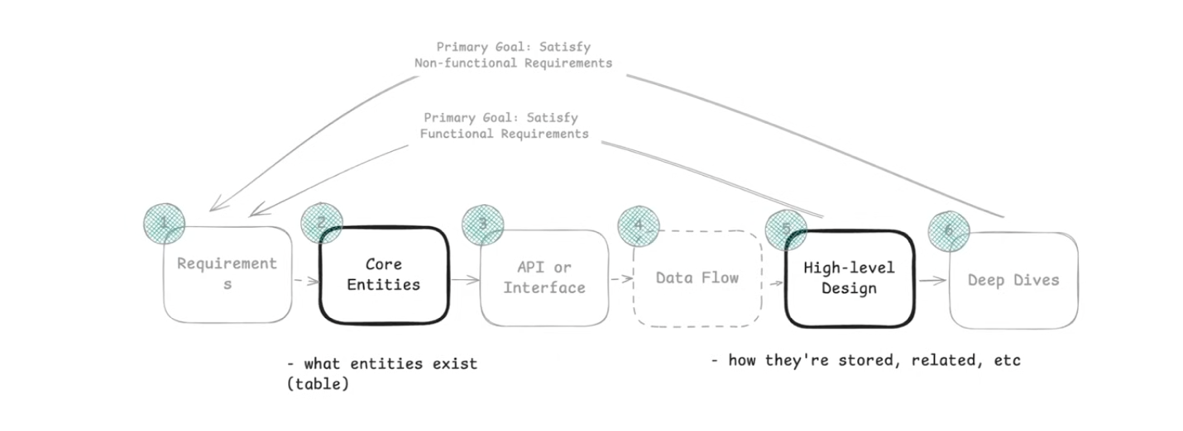

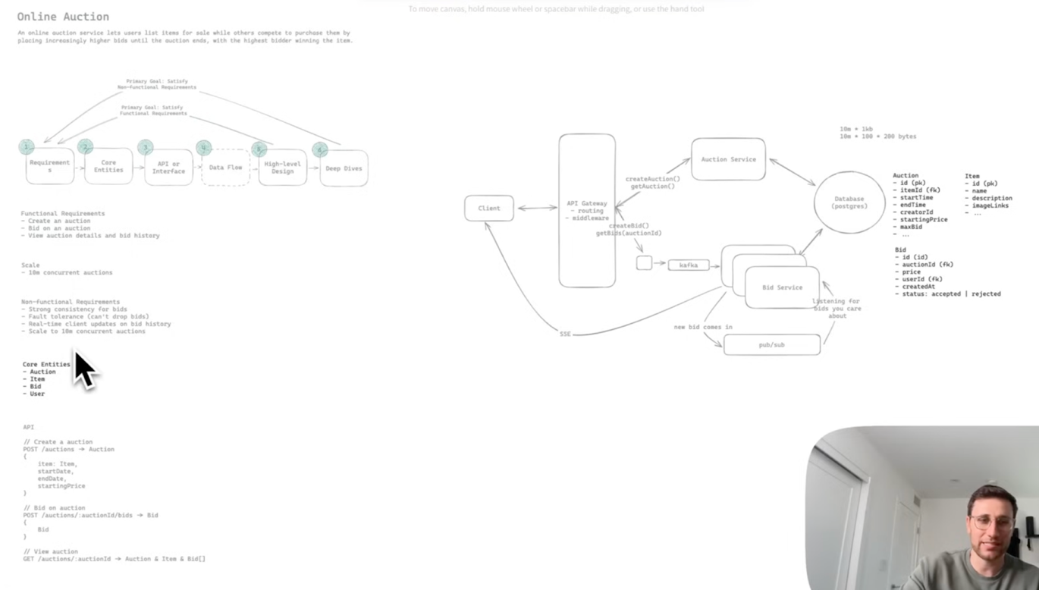

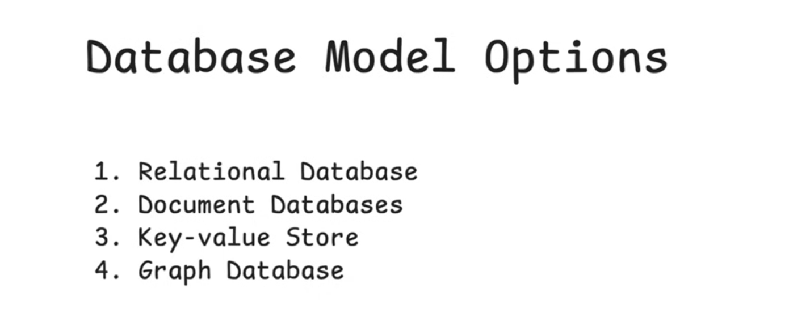

Most of the time, the right answer is a relational database.

Unless you have significant experience and, with it, strong opinions about another database, my recommendation is to stick with [PostgreSQL](https://www.hellointerview.com/learn/system-design/deep-dives/postgres).

**1. Relational Database** - PostgreSQL, MySQL

Relational databases organize data into tables with fixed schemas, where rows represent entities and columns represent attributes. They enforce relationships through [foreign keys](https://www.hellointerview.com/learn/system-design/core-concepts/data-modeling#entities-keys-relationships) and provide [ACID](https://en.wikipedia.org/wiki/ACID) guarantees for transactions.

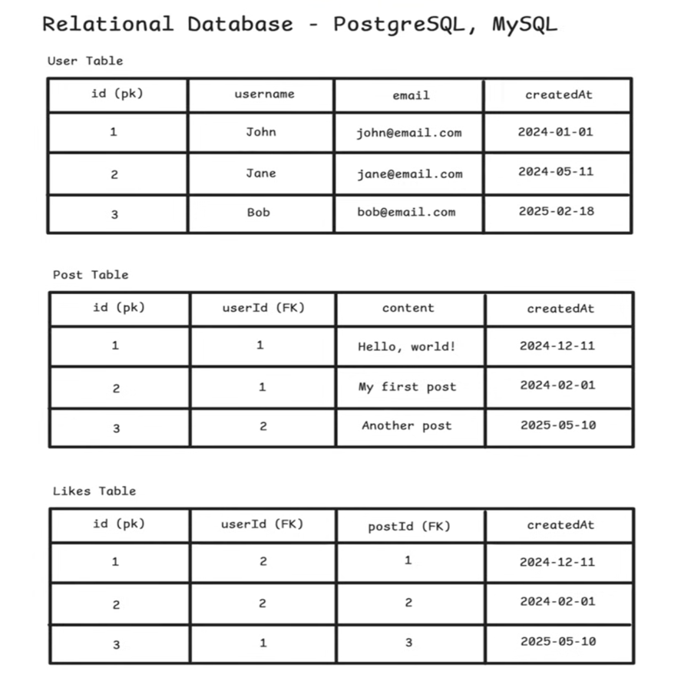

SQL is great at handling complex queries. If you need to fetch "all posts by users that a given user follows, ordered by recency," joins make that straightforward. However, be careful with multi-table joins like this - they can become performance traps at scale.

In interviews, mentioning complex reporting-style queries often raises yellow flags about performance, so you'll want to think through whether they're actually performant enough or if you need denormalized views, caching, or pre-computed results. And when strong consistency is a [non-functional requirement](https://www.hellointerview.com/learn/system-design/in-a-hurry/delivery#non-functional-requirements), like ensuring payments don't double-charge or inventory doesn't oversell, SQL's ACID guarantees are the right tool for the job.

**The usual knock on relational databases is scalability, but this is often exaggerated. Modern SQL databases scale with techniques like read replicas, sharding, connection pooling, and caching. Some of the largest companies in the world (Facebook, Airbnb, Stripe) rely on relational foundations. Scaling isn't just about the database you choose, but how you architect around it.**

**2. Document Database** - MongoDB, Firestore, and CouchDB

Document databases store data as JSON-like documents with flexible schemas, making them good for rapidly evolving applications where you don't know all your data fields upfront.

Your data modeling becomes more about nesting and embedding related information within documents rather than normalizing across tables.

Notice how the same data from our SQL example gets restructured. Instead of separate tables, we embed posts directly within each user document.

This eliminates joins but means updating a post requires finding and modifying the entire user document.

User Collection:

{

  "_id": "507f1f77bcf86cd799439011",

  "username": "john_doe",

  "email": "john@example.com",

  "posts": [

    {

      "content": "Hello, world!",

      "created_at": "2024-01-01T10:00:00Z"

    },

    {

      "content": "My first post",

      "created_at": "2024-01-01T10:05:00Z"

    }

  ],

  "created_at": "2024-01-01T10:00:00Z"

}

**System design interviews intentionally scope functional requirements to a clear, concise set. This means you're unlikely to have "evolving schemas" in the first place, which removes the main reason to choose document databases.**

**Only consider them if your interviewer explicitly mentions rapidly changing data structures.**

**When to consider over SQL:** When your schema changes frequently, when you have deeply nested data that would require many joins in SQL, or when different records have vastly different structures. A user profile system where some users have extensive work histories while others have minimal data fits this pattern.

**Data modeling impact:** You'll denormalize more aggressively, embedding related data within documents to avoid expensive lookups across collections. This trades storage space and update complexity for read performance.

**3. Key-Value Stores -** [Redis](https://www.hellointerview.com/learn/system-design/deep-dives/redis), [DynamoDB](https://www.hellointerview.com/learn/system-design/deep-dives/dynamodb), and [Memcached](https://memcached.org/).

Key-value stores provide simple lookups where you fetch values by exact key match. They're extremely fast but offer limited query capabilities beyond that basic operation.

**When to consider over SQL:** For caching, session storage, feature flags, or any scenario where you only need to look up data by a single identifier. They're also good for high-write scenarios where you need maximum performance and don't need complex queries.

**"Over SQL" is misleading here. In practice, you'll often use both together. SQL as your source of truth with a key-value cache (like Redis) in front for hot data. This gives you fast access without sacrificing durability or complex queries.**

**Data modeling impact:** Your schema becomes very flat. You'll [denormalize](https://www.hellointerview.com/learn/system-design/core-concepts/data-modeling#normalization-vs-denormalization) heavily and duplicate data across multiple keys to support different access patterns, since you can't join or query across relationships. This is great for reads but terrible for consistency when data changes.

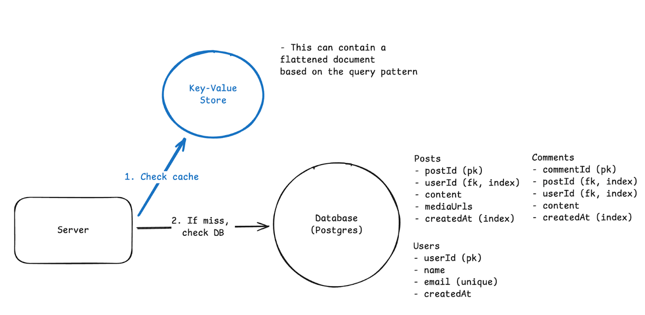

**4. Wide-Column Databases -** Cassandra, HBase

Wide-column databases organize data into column families where rows can have different sets of columns. They're optimized for massive write-heavy workloads and time-series data.

When a user creates a new post, you just add a new column to their row. This makes writes extremely fast since you're not modifying existing data, just appending new columns.

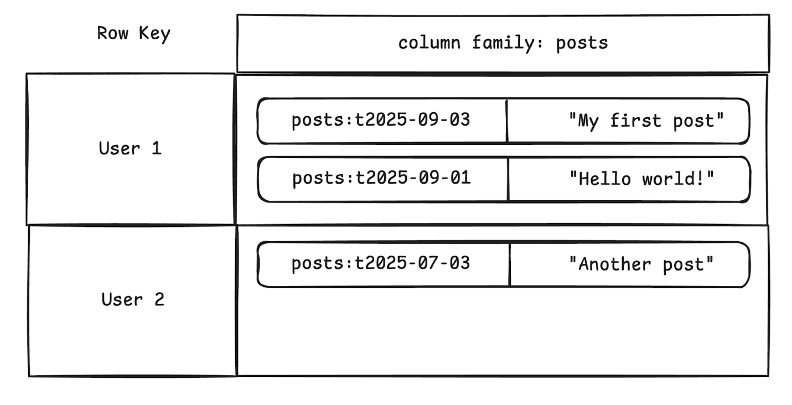

**When to consider over SQL:** When you have enormous write volumes, time-series data, or analytics workloads where you primarily append data and run aggregations. Think telemetry, event logging, or IoT sensor data.

**Data modeling impact:** You'll design around query patterns even more than with SQL, often duplicating data across different column families to support various access patterns. Time becomes a first-class citizen in your modeling.

**5. Graph Databases** - Neo4j, Amazon Neptune

Graph databases store data as nodes and edges, optimizing for traversing relationships between entities.

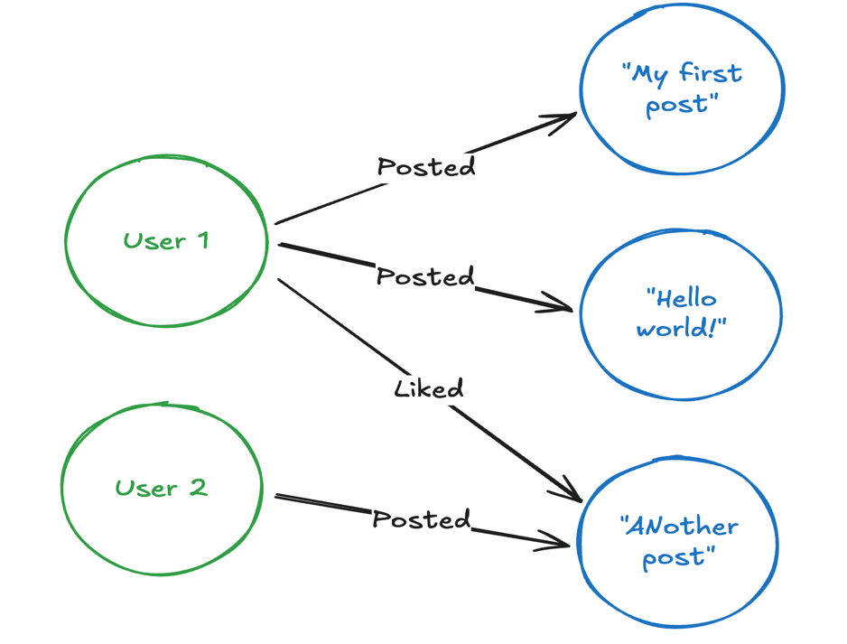

**When to consider over SQL:** Honestly? Almost never in interviews. The classic examples are social networks and recommendation engines, but even Facebook models their social graph with MySQL. If it's good enough for the world's largest social network, it's probably good enough for your interview.

**Graph databases are a common mistake in interviews. They sound sophisticated but add unnecessary complexity. Even "graph-heavy" companies like LinkedIn and Twitter use SQL for their core relationship data. Other databases can handle the primary query patterns without the operational complexity that comes with specialized graph systems.**

**Schema Design Fundamentals**

Once you've picked your database type, you need to design a schema that supports your system's requirements.

**Three key factors:**

Everything flows from three key factors and were likely already determined during the [requirements gathering](https://www.hellointerview.com/learn/system-design/in-a-hurry/delivery#requirements-5-minutes) and [api design](https://www.hellointerview.com/learn/system-design/in-a-hurry/delivery#api-or-system-interface) phases.

1. **Data Volume: Where can Data live? (Single DB vs Distributed)**
2. **Access Patterns: How is data queried? (drives indexes & structure)**

[It comes from your API, and most imp factor]

1. **Consistency Requirements: How strict? (ACID vs eventual consistency)**

**Data volume** determines where your data can physically live. A social media app with millions of users might need data spread across multiple data stores, which drives schema design choices. If user data and post data need to live on separate systems for performance or organizational reasons, they necessarily need distinct schemas with careful consideration of how they reference each other.

**Access patterns** are the most important factor and drive most of your design decisions. How will your data be queried? A news feed that loads "recent posts by followed users" suggests you'll want denormalized data or carefully designed indexes. An analytics dashboard that aggregates data across time periods might need different table structures entirely. This comes naturally from your APIs. Just ask what queries will I need to support each endpoint?

**Consistency requirements** determine how tightly coupled your data can be. Financial transactions need strong consistency (no partial charges), which often means keeping related data in the same database with ACID guarantees. But a user's activity feed can handle eventual consistency (it's okay if a like shows up a few seconds later), which allows you to distribute that data across separate systems with different schemas optimized for different access patterns.

**In interviews, explicitly tie your schema choices back to these factors. For example, *"Since we need to load feeds quickly and likes can be eventually consistent, I'll denormalize like counts into the posts table."* That shows you're reasoning instead of memorizing patterns.**

All of the schema design techniques that follow (entities, keys, normalization, indexes, sharding) are just tools to address these three factors.

**Entities, Keys & Relationships**

Once you’ve identified your [core entities](https://www.hellointerview.com/learn/system-design/in-a-hurry/delivery#core-entities-2-minutes), the next step is to map them into tables (or collections) with clear identifiers and relationships.

For a social media app, you might have users, posts, comments, and likes. Each entity needs a **primary key** to identify individual records. Use system-generated IDs like user_id or post_id rather than business data like email addresses. System-generated keys stay stable even when business rules change.

users: id (PK), username, email

posts: id (PK), user_id (FK → users.id), content, created_at

comments: id (PK), post_id (FK → posts.id), user_id (FK → users.id), content

likes: user_id (FK → users.id), post_id (FK → posts.id)

This shows the core relationships: each post belongs to one user (posts.user_id), each comment belongs to one post and one user, and likes connect users to posts. The (PK) marks primary keys, (FK) marks foreign keys with arrows showing what they reference.

In interviews, just pick an obvious primary key and explain why. "post_id will be our primary key so we can uniquely identify each post and reference it from comments and likes.”

With entities defined, connect them with relationships:

* **One-to-many (1:N):** a user has many posts, a post has many comments.
* **Many-to-many (N:M):** users like many posts, posts are liked by many users.
* **One-to-one (1:1):** rare in practice, often a sign that two tables should just be merged.

These relationships are enforced through **foreign keys** in SQL (e.g., posts.user_id → users.user_id) or by application logic in NoSQL. Foreign keys help ensure referential integrity - meaning they prevent orphaned records like a post referencing a user that doesn't exist, or comments pointing to deleted posts. However, they come at a cost because the database has to validate each insert/update. At very large scale, some companies drop them for write performance and enforce integrity at the application level. In an interview, mentioning them shows you understand the trade-off.

Finally, layer in **constraints** like NOT NULL, UNIQUE, or CHECK. These enforce correctness at the database level (emails must be unique, prices must be positive). They protect data quality, though they also add write overhead.

Keep your schema grounded in the problem domain: users, tweets, follows if you're modeling Twitter, not abstract "entities" and "relationships." Then show how keys, foreign keys, and constraints keep that model correct and scalable.

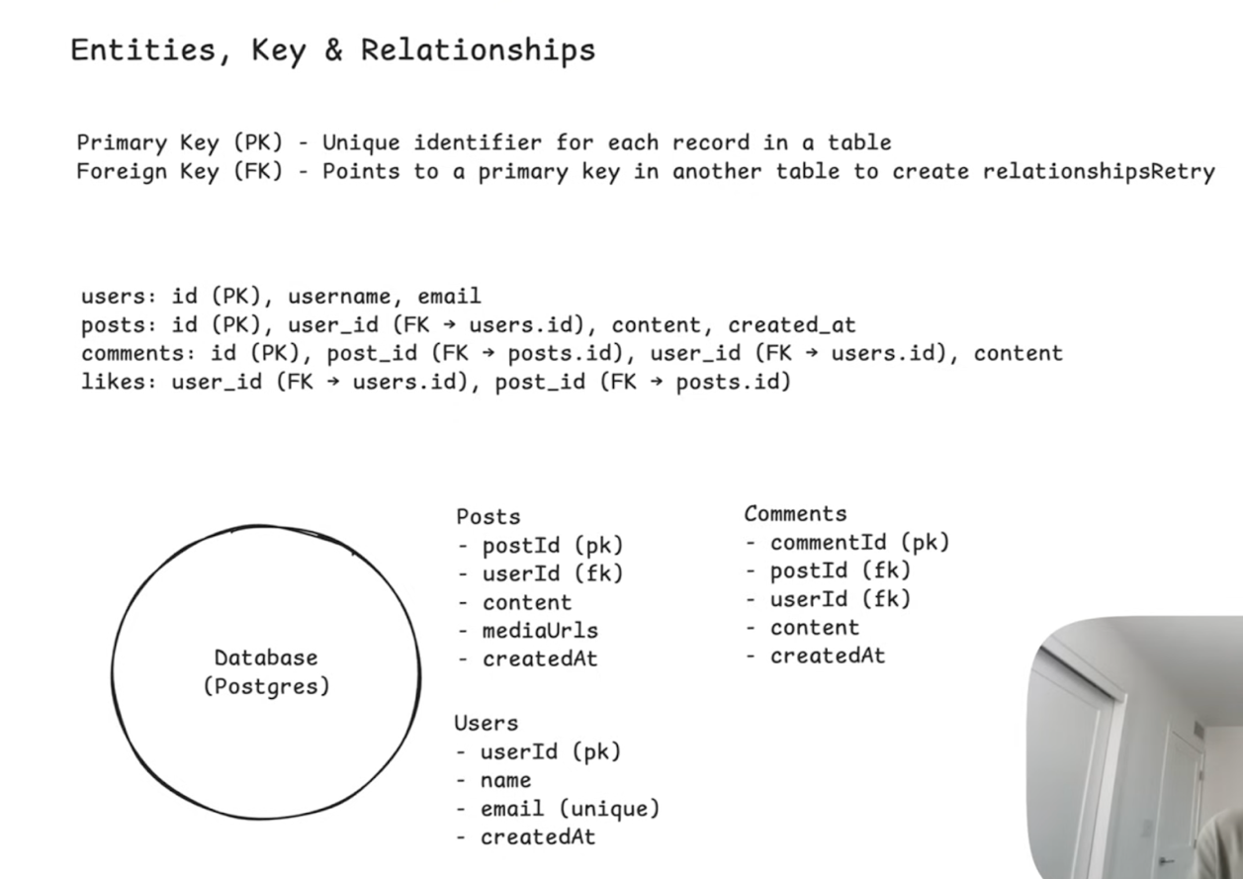

**Indexing for Access Patterns**

Indexes are data structures that help the database find records quickly without scanning every row. Think of them like the index in a book - instead of reading every page to find "normalization," you look it up in the index and jump directly to page 149. While data modeling in an interview, you'll typically want to callout which columns are indexed and why.

Your indexes should directly support your most imp queries. For a social media app:

* Index on posts.user_id to quickly find all posts by a user
* Index on posts.created_at to load recent posts chronologically
* Composite index on (user_id, created_at) to efficiently load a user's recent posts

In interviews, connect your indexes directly to your API endpoints. "The GET /users/{id}/posts endpoint needs an index on posts.user_id" shows you're thinking about real query performance.

**Normalization vs Denormalization**

Normalization means storing each piece of information in exactly one place. User data lives only in the users table, not duplicated across other tables.

This prevents data anomalies where updates happen in one place but not another, leaving your system with inconsistent state.

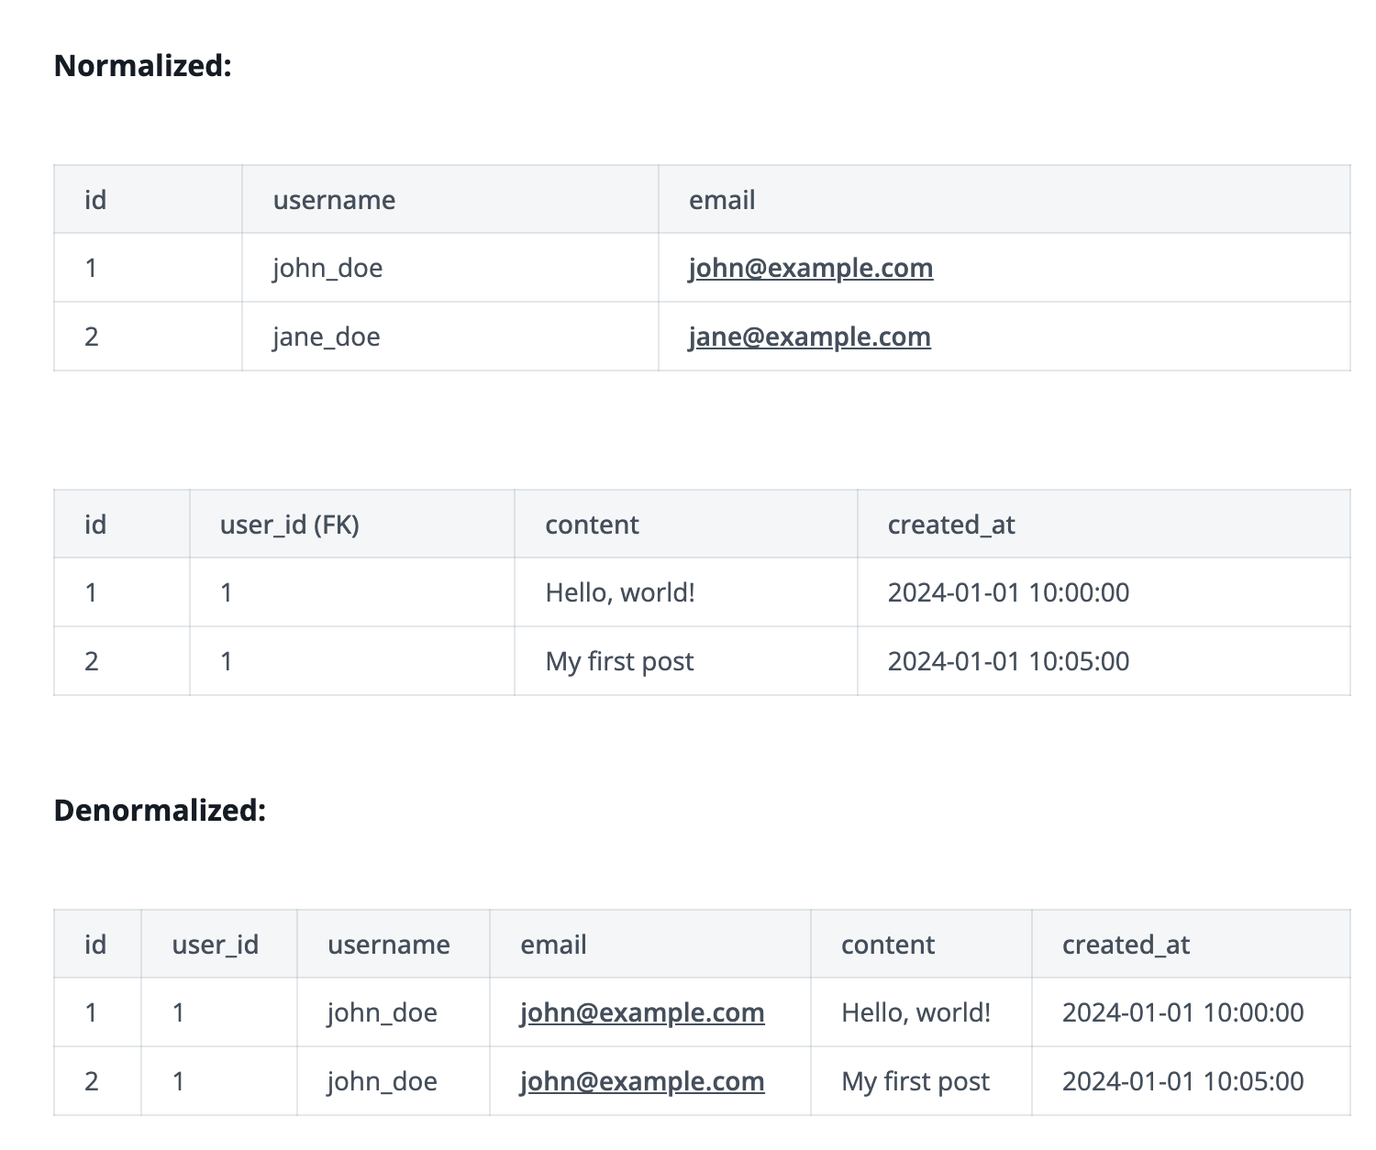

In the denormalized version, if a user changes their username, you'd have to update every single post they've ever made. Miss one update and you have inconsistent data.

In system design interviews, start with a clean normalized model and denormalize only when needed. Avoid repeating data in your schema design. Repeating data is wasteful and creates consistency problems that are much harder to solve than the performance problems you're trying to avoid.

There are a few key exceptions where denormalization might make sense:

* Analytics and reporting systems where you're aggregating data that changes infrequently
* Event logs and audit trails where you're capturing a snapshot of data at a point in time
* Heavily read-optimized systems like search engines where consistency is less critical than speed

That said, even if you need denormalized quick access for performance, you can just put a cache

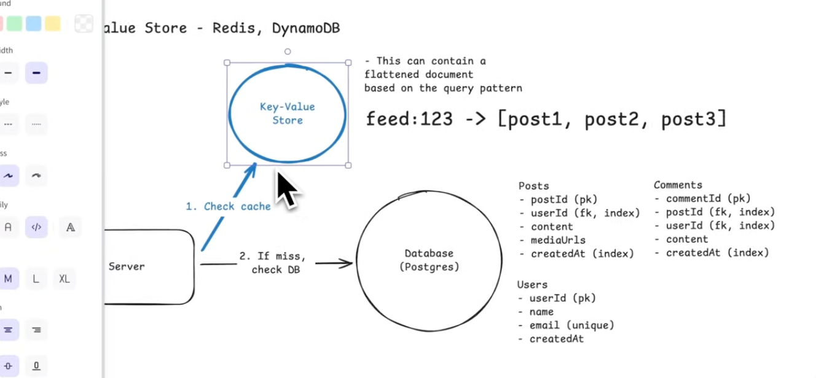

 in front that has a denormalized representation of the data. Your source of truth stays clean and normalized, but your cache can have pre-computed joins, aggregations, or whatever structure makes reads fast.

**Scaling and Sharding**

When your data gets too large for a single database, you need to [shard](https://www.hellointerview.com/learn/system-design/core-concepts/sharding) it across multiple machines. The key is choosing a partition strategy that keeps related data together.

Shard by the primary access pattern. If you mostly query "posts by user," shard by user_id. This keeps a user's posts on the same database, avoiding expensive cross-shard queries. If you frequently query recent posts across all users, consider sharding by time ranges.

Avoid cross-shard queries whenever possible. If your timeline feature needs to show posts from multiple users a user follows, and you've sharded by user_id, you'll have to query multiple shards and merge results. This is expensive and complex.

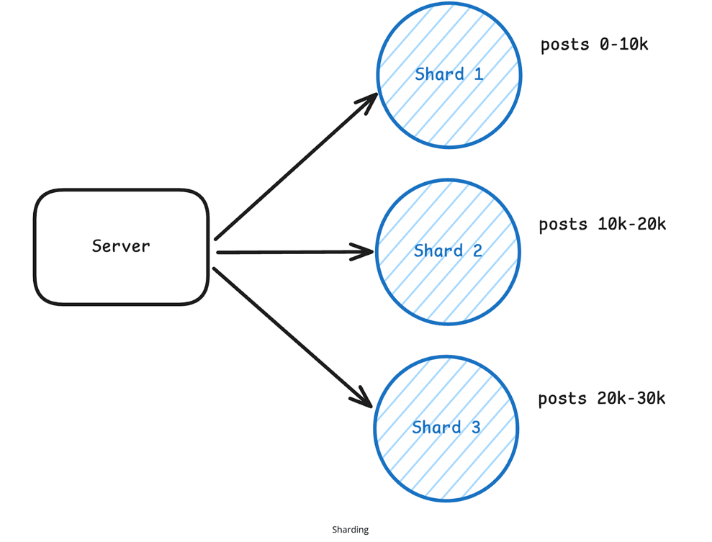

Your choice of shard key is often permanent and affects every query. Think carefully about your primary access patterns before choosing how to shard your data.

**Conclusion**

Data modeling is a core part of system design interviews, but it's not the focus. Your goal is to show that you can design a reasonable schema that supports your system's requirements, then move on.

Start by outlining your core entities early in the interview. Then, when introducing a database component during the high-level design:

* Determine the type of database you'll use
* List the columns needed to fulfill the functional requirements for each entity
* Specify primary and foreign keys for each relationship
* Determine which columns need indexes (if any)
* Determine whether you need to denormalize for performance
* Consider whether [sharding](https://www.hellointerview.com/learn/system-design/core-concepts/sharding) is necessary. If yes, choose a shard key that matches your main access pattern.

At the end, your whiteboard should look something like this:

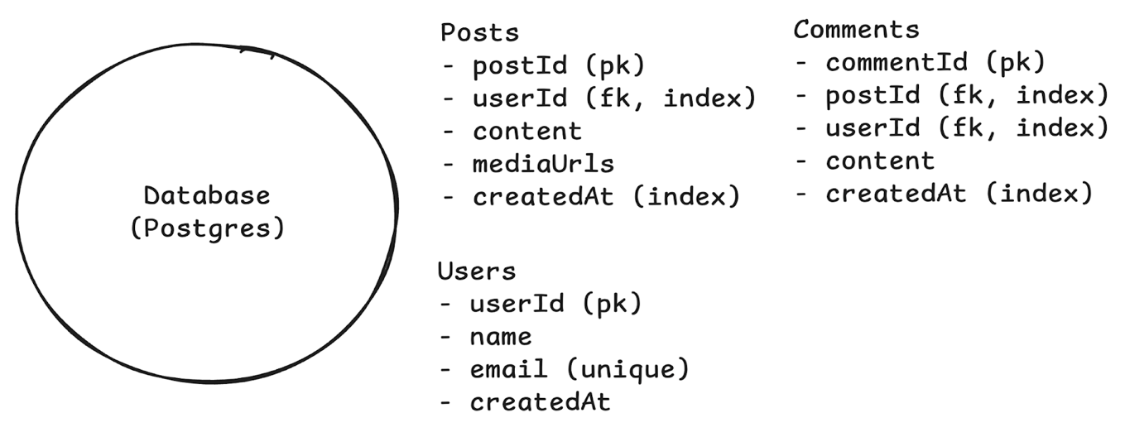

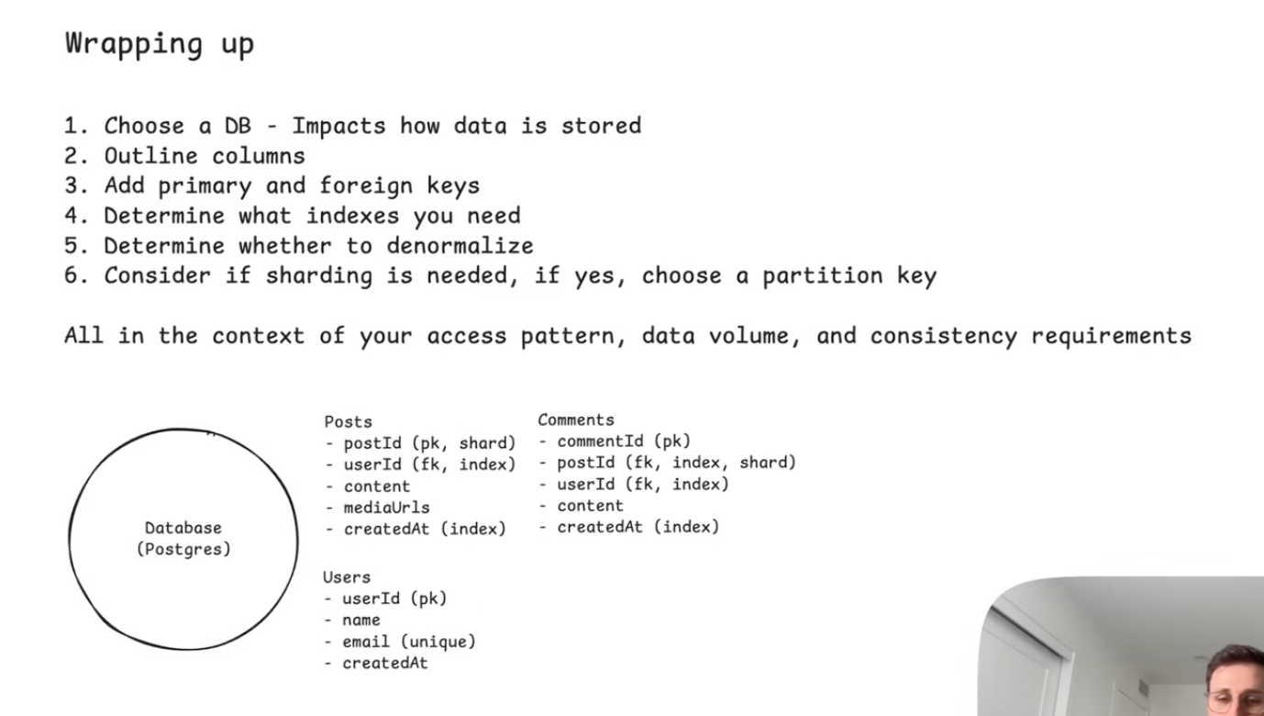

**Caching**

What is caching?

A cache is just a temporary storage that keeps recently used data handy so you can get it much faster next time.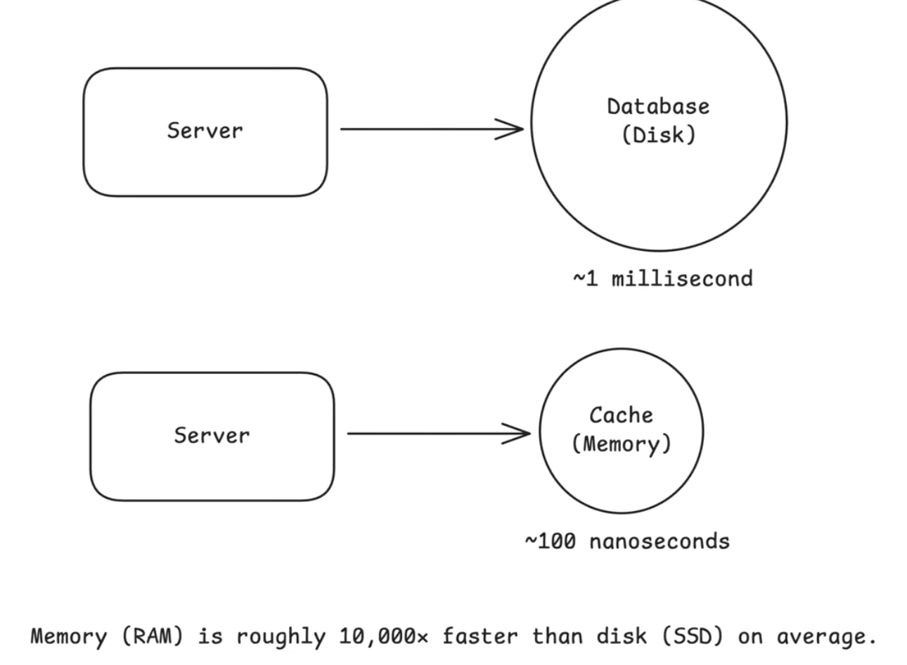

1. **Where to cache?**

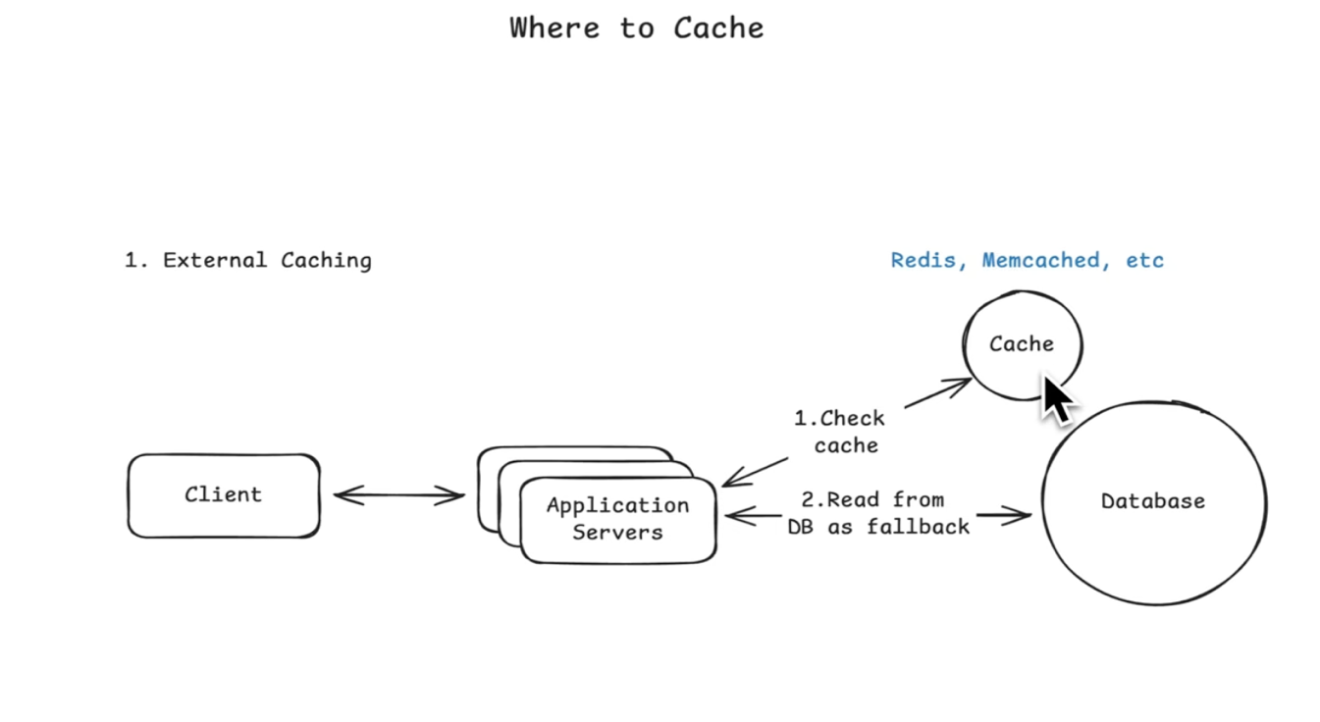

An external cache is a standalone cache service that your application talks to over the network. This is what most people think of when they hear caching.

You store frequently accessed data in something like [Redis](https://www.hellointerview.com/learn/system-design/deep-dives/redis) or [Memcached](https://memcached.org/) so you do not have to hit the database every time.

External caches scale well because every application server can share the same cache.

They also support eviction policies like LRU and TTL so your memory footprint stays controlled.

**In system design interviews, external caching with Redis is the default answer when discussing caching strategies. Interviewers expect you to mention it for any high-traffic system. Start here, then layer on other caching types such as CDN or client-side caching only if the problem calls for them.**

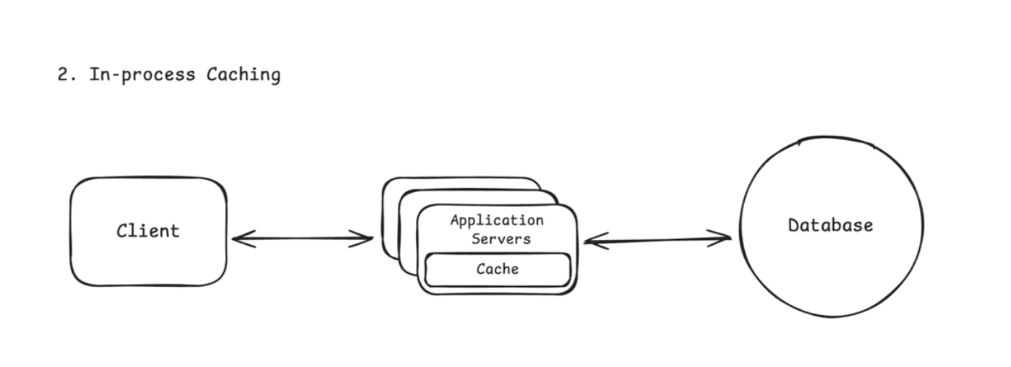

Most candidates, and engineers, overlook the fact that servers run on machines with a lot of memory. As hardware improves, this becomes increasingly true. You can use that memory to cache data directly inside the application process instead of always calling out to Redis or the database.

The idea is simple: if your service keeps requesting the same small pieces of data again and again, store them in a local cache inside the process. Reads from local memory are even faster than reads from Redis because they avoid any network call.

This light-weight form of caching makes sense for small pieces of data that are requested frequently like:

* Configuration values
* Feature flags
* Small reference datasets
* Hot keys
* Rate limiting counters
* Precomputed values

In-process caching is blazing fast, but it comes with obvious limitations. Each instance of your application has its own cache, so cached data is not shared across servers. If one instance updates or invalidates a cached value, the others will not know.

Use in-process caching for small, frequently accessed values that rarely change. It is great for speed but not a replacement for Redis. In system design interviews, mention this only as an **optimization layer** after you have already introduced an external cache.

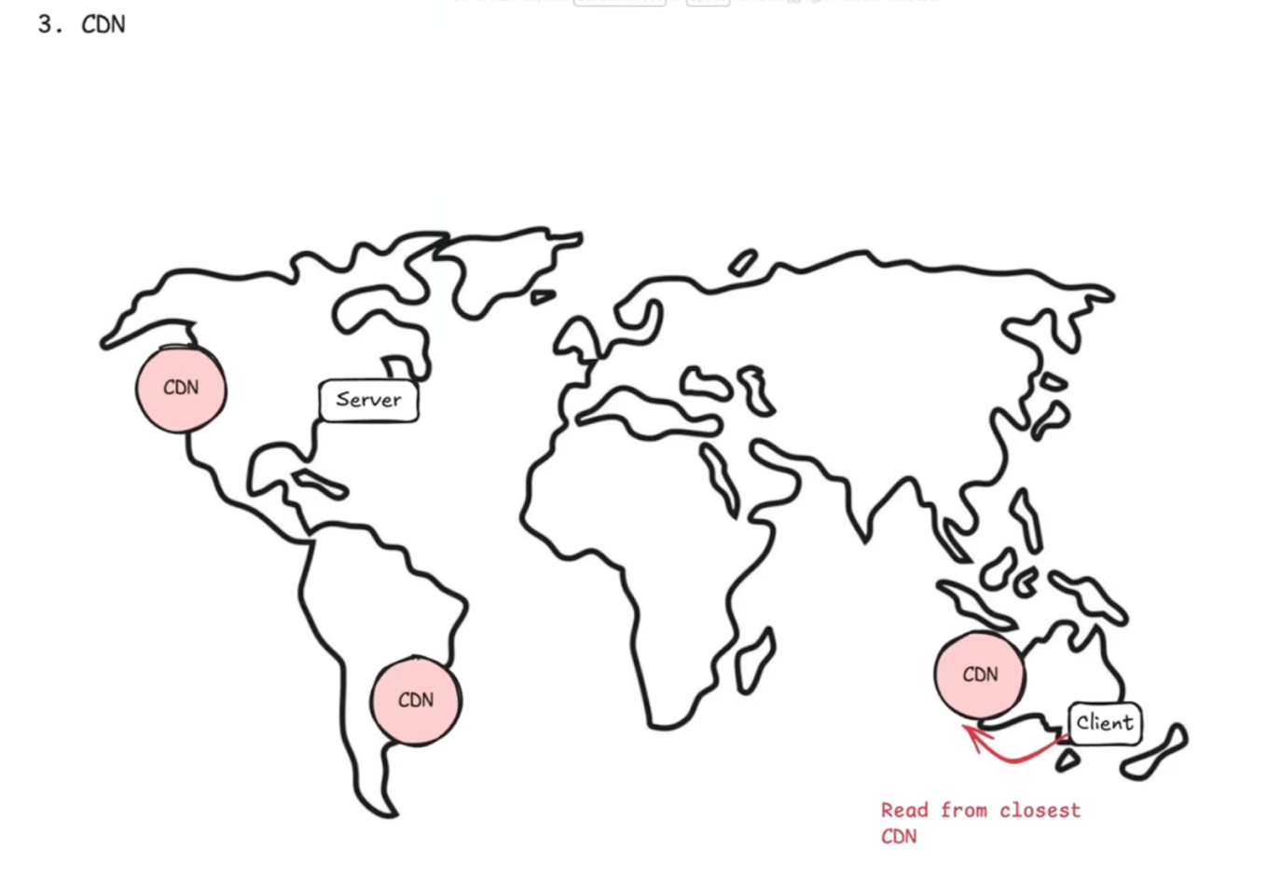

A CDN is a geographically distributed network of servers that caches content close to users. Instead of every request traveling to your origin server, a CDN stores copies of your content at edge servers around the world.

Modern CDNs like Cloudflare, Fastly, and Akamai can cache much more than static files. They can also cache public API responses, HTML pages, and even run edge logic to personalize content or enforce security rules before requests reach your servers. But the most common and most impactful use of a CDN is still media delivery.

How it works:

* A user requests an image from your app.
* The request goes to the nearest CDN edge server.
* If the image is cached there, it is returned immediately.
* If not, the CDN fetches it from your origin server, stores it, and returns it.
* Future users in that region get the image instantly from the CDN.

Without a CDN, every image request travels to your origin. If your server is in Virginia and the user is in India, that adds 250–300 ms of latency per request. With a CDN, the same image is served from a nearby edge server in 20–40 ms. That is a massive performance difference.

Even though modern CDNs can cache API responses and dynamic content, in system design interviews the safest time to introduce a CDN is when your system serves static media at scale. Start with that reason first, then expand only if the problem calls for more.

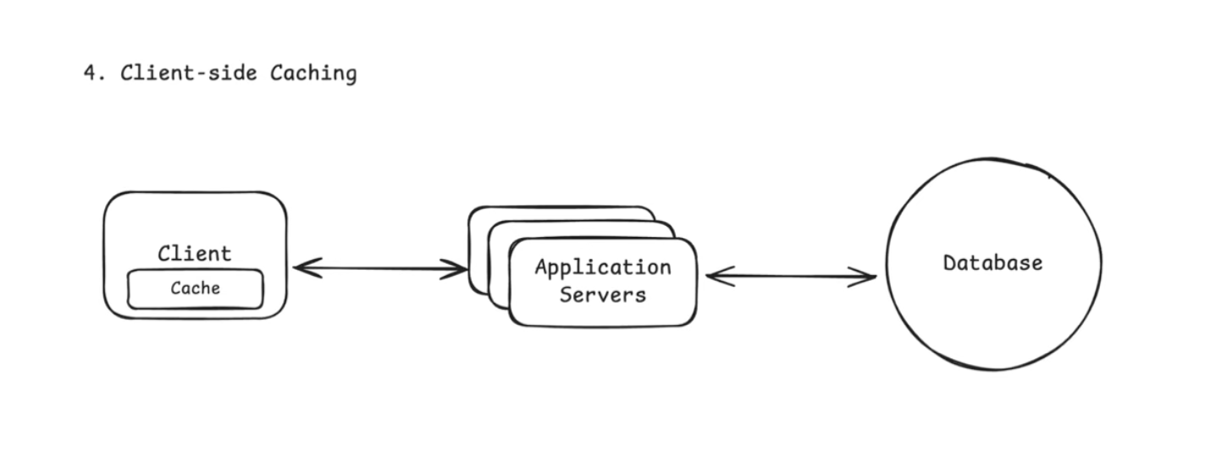

Client-side caching stores data close to the requester to avoid unnecessary network calls. This usually means the user's device, like a browser (HTTP cache, localStorage) or mobile app using local memory or on-device storage.

But it can also mean caching within a client library. For example, Redis clients cache cluster metadata like which nodes are in the cluster and which slots are assigned to them. That way, the client can route requests directly to the right node without querying the cluster on every operation.

For user-facing caching, you have limited control from the backend. Data can go stale and invalidation is harder. The [Strava app](https://www.hellointerview.com/learn/system-design/problem-breakdowns/strava) keeps your run data on the device while you are offline and syncs it later. A browser reusing a previously downloaded image from disk is also caching.

**B. Cache Architectures:**

1. Cache-Aside (Lazy Loading)

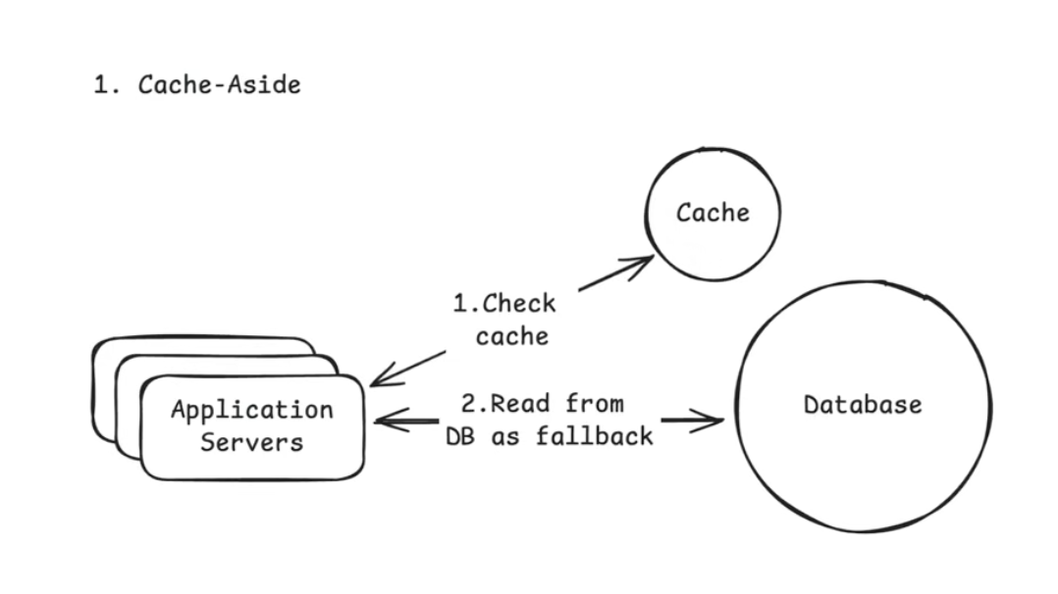  
Only architecture is important to remember for interviews.

How it works:

* Application checks the cache.
* If the data is there, return it.
* If not, fetch from the database, store it in the cache, and return it.

Cache-aside only caches data when needed, which keeps the cache lean. The downside is that a cache miss causes extra latency.

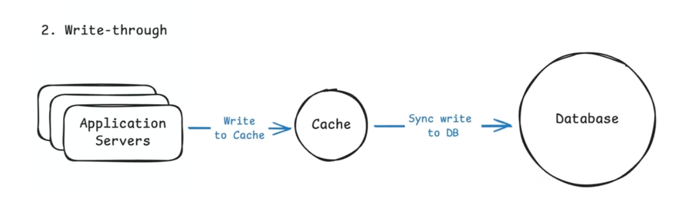

Use this when **reads must always return fresh data** and your system can tolerate slightly slower writes.

3. Write-Behind (Write-Back) Caching

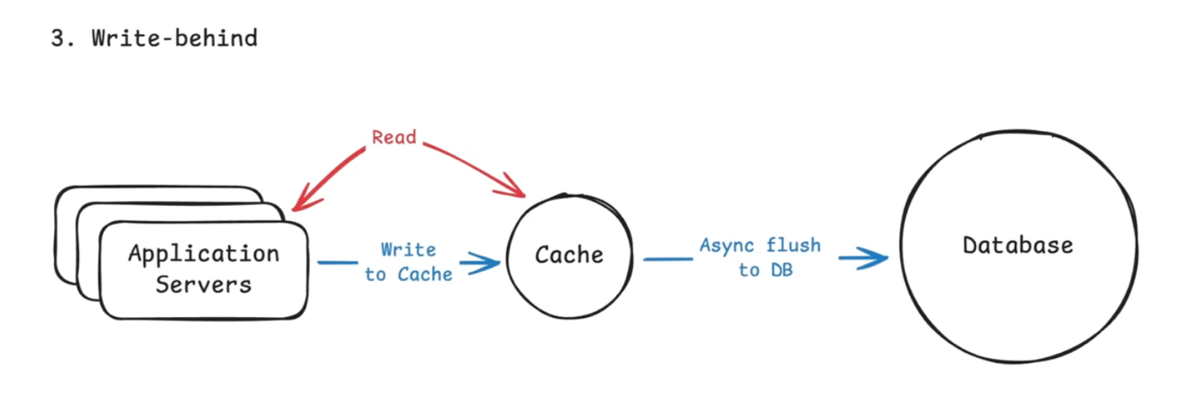

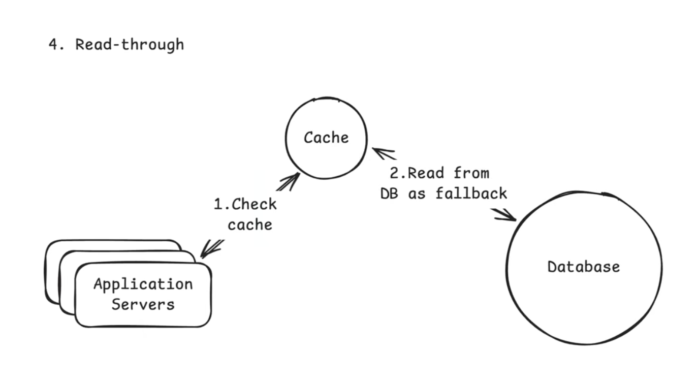

**C. Cache Eviction Policies**

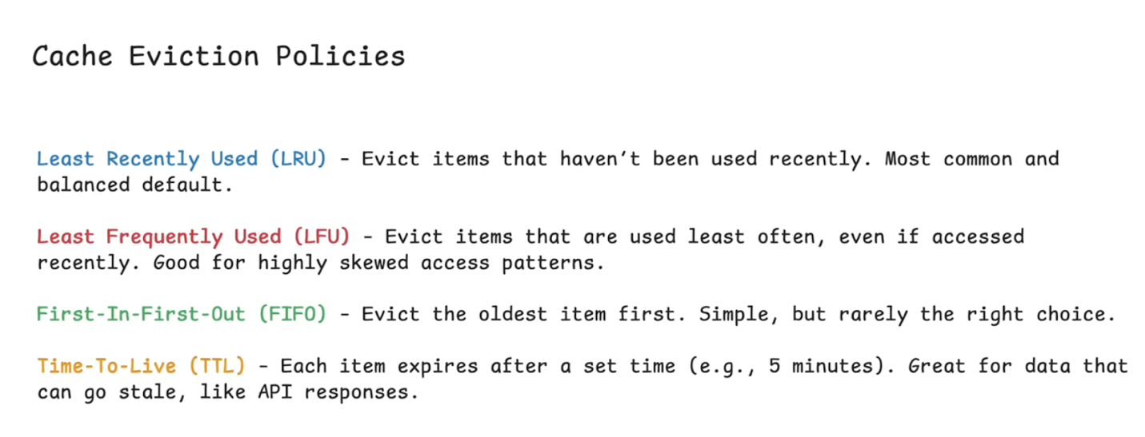

**D. Common Issues**

There's a famous saying in Computer Science, There’s only two hard problems in Computer Science: **Naming things and cache invalidation.**

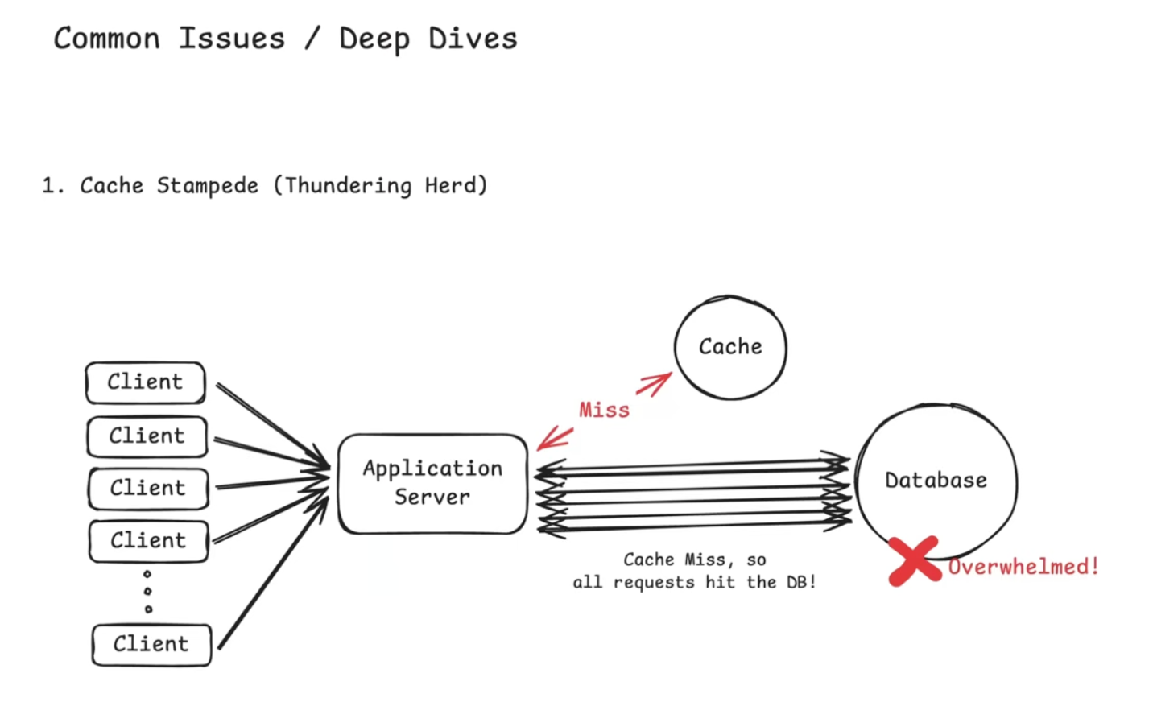

A cache stampede happens when a popular cache entry expires and many requests try to rebuild it at the same time.

There is a brief window, even if only a second, where every request misses the cache and goes straight to the database. Instead of one query, you suddenly have hundreds or thousands, which can overload the database.

For example, imagine your system caches the homepage feed with a TTL of 60 seconds. When the cache expires at exactly 12:01:00, every request at that moment misses the cache and queries the database. If traffic is high, this spike can overwhelm the database and cause cascading failures.

How to handle it:

* **Request coalescing (single flight):** Allow only one request to rebuild the cache while others wait for the result. This is the most effective solution.
* **Cache warming:** Refresh popular keys proactively before they expire. This only helps when using TTL-based expiration. If you invalidate cache on writes instead, warming does not prevent stampedes.

**2. Cache Consistency**

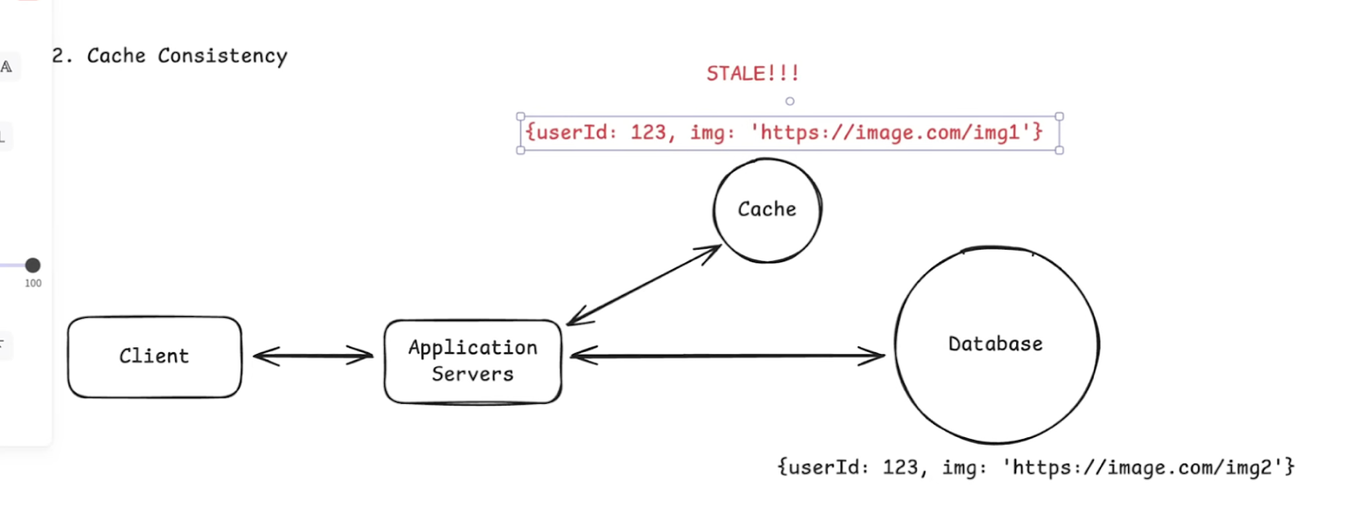

Most common in interview

Cache consistency problems are some of the most commonly discussed in system design interviews. They happen when the cache and database return different values for the same data. This is common because most systems read from the cache but write to the database first. That creates a window where the cache still holds stale data.

For example, if a user updates their profile picture, the new value is written to the database but the old value might still be in the cache. Other users may see the outdated profile picture until the cache eventually refreshes.

There is no perfect solution. You choose a strategy based on how fresh the data must be.

How to handle it:

* **Cache invalidation on writes:** Delete the cache entry after updating the database so it gets repopulated with fresh data.
* **Short TTLs for stale tolerance:** Let slightly stale data live temporarily if eventual consistency is acceptable.
* **Accept eventual consistency:** For feeds, metrics, and analytics, a short delay is usually fine.

3. Hot Keys

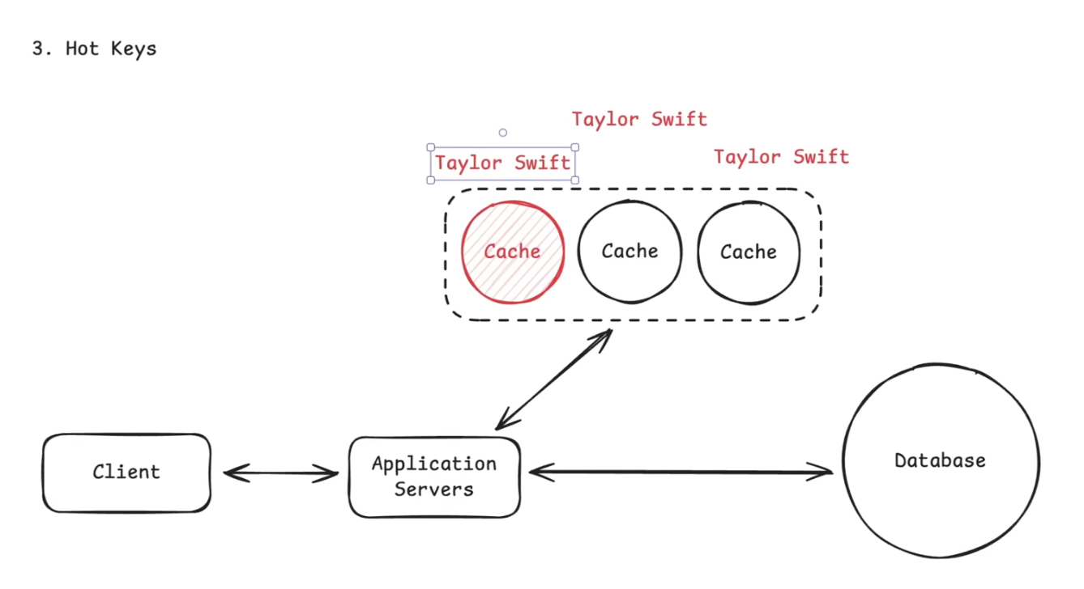

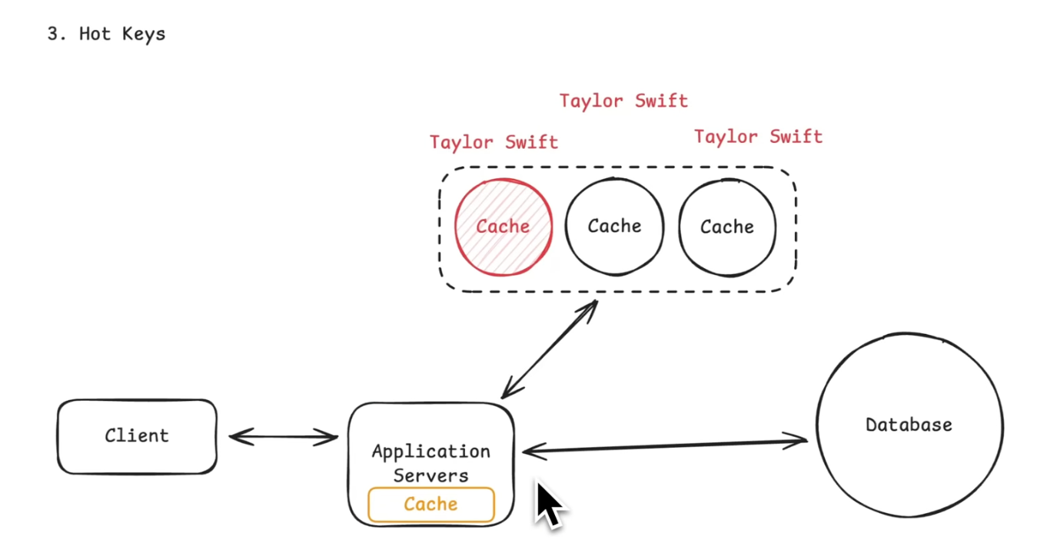

A hot key is a cache entry that receives a huge amount of traffic compared to everything else. Even if the cache hit rate is high, a single hot key can overload one cache node or one Redis shard and become a bottleneck.

For example, if you are building Twitter and everyone is viewing Taylor Swift’s profile, the cache key for her user data (user:taylorswift) may receive millions of requests per second. That one key can overload a single Redis node even though everything is working “correctly.”

How to handle it:

* **Replicate hot keys:** Store the same value on multiple cache nodes and load balance reads across them.
* **Add a local fallback cache:** Keep extremely hot values in-process to avoid pounding Redis.
* **Apply rate limiting:** Slow down abusive traffic patterns on specific keys.

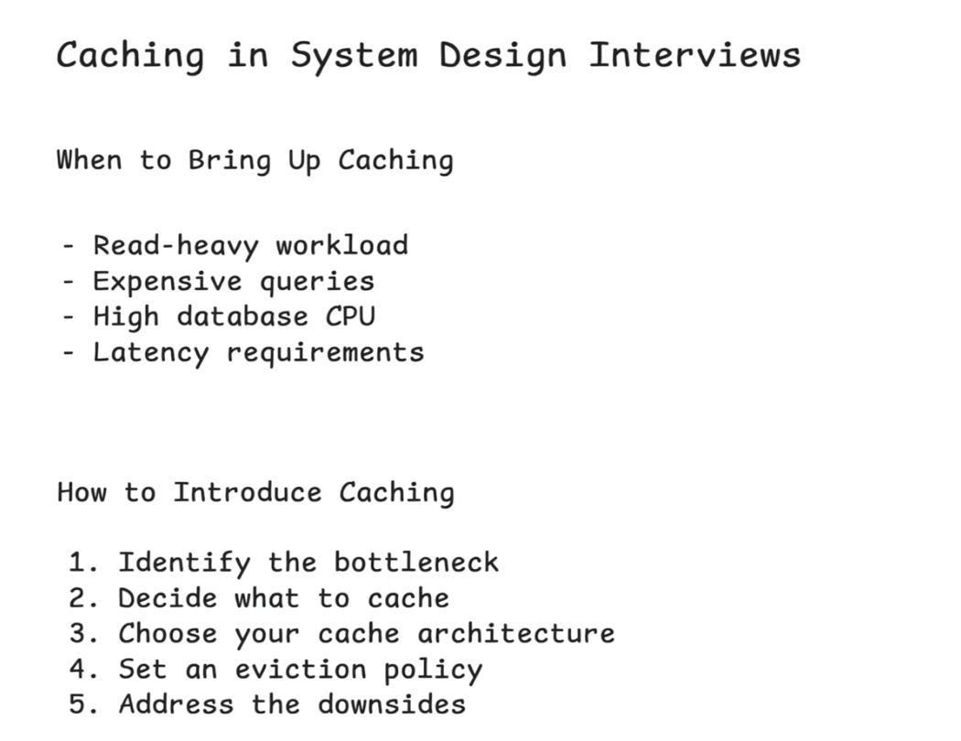

**Sharding**

**When a single database can’t keep up anymore, you have only one real option: Split your data across multiple machines.** This is called sharding.

People often use the words "partitioning" and "sharding" to mean the same thing. Technically they are slightly different. Partitioning usually refers to splitting data within a single database instance, often by table ranges or hash partitions. Sharding means splitting data across multiple machines. In practice most engineers use the terms loosely, so do not get hung up on the wording.

**What is Partitioning?**

Partitioning means splitting a large table into smaller pieces inside a single database instance. It does not add more machines. Instead it organizes data so the database can work more efficiently.

There are two common types of partitioning:

**Horizontal partitioning**: Split rows across partitions. For example, one partition per year of orders. Same columns, fewer rows per partition.

**Vertical partitioning**: Split columns across partitions. For example, keep frequently accessed columns in one partition and large or rarely used columns in another. Same rows, fewer columns per partition.

**What is Sharding?**

Sharding is horizontal partitioning across multiple machines. Each shard holds a subset of the data, and together the shards make up the full dataset.

For example, if we partitioned our order data by id

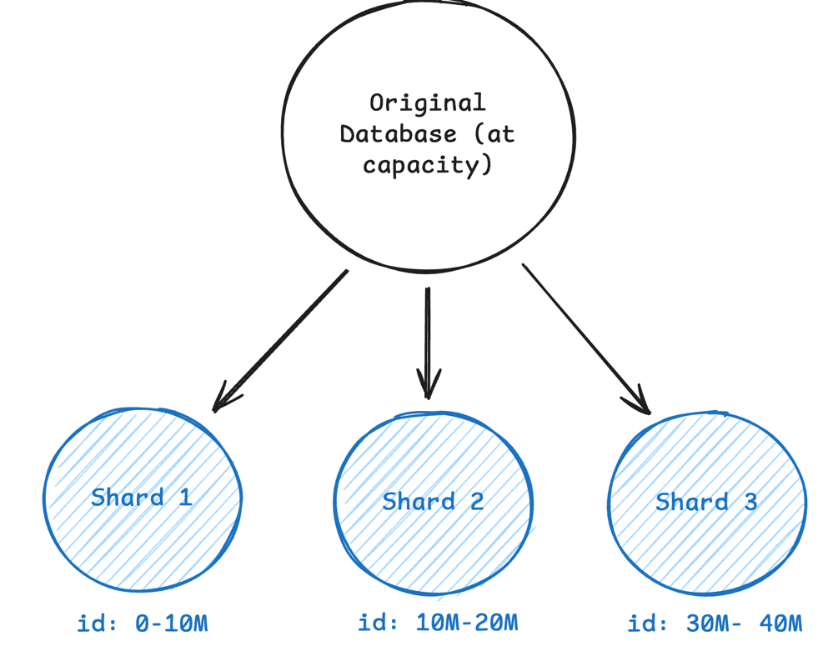

Each shard is a standalone database with its own CPU, memory, storage, and connection pool. No single machine holds all the data or handles all the traffic, which allows both storage capacity and read/write throughput to scale as you add more shards.

Sharding solves scaling but introduces new problems. You now have to choose a shard key, route queries to the right shard, avoid hotspots, and rebalance data as shards grow.

**How to Shard Your Data**

When you decide to shard, you need to make two decisions that work together:

**What to shard by**: The field or column you use to split the data. It defines how the data is grouped.

**How to distribute it**: The rule for assigning those groups to shards. It defines how the data is distributed across machines.

**1. Choosing Your Shard Key**

In an interview, a common statement is "I'm going to shard by [field]". The key is knowing what field to use as your shard key and why.

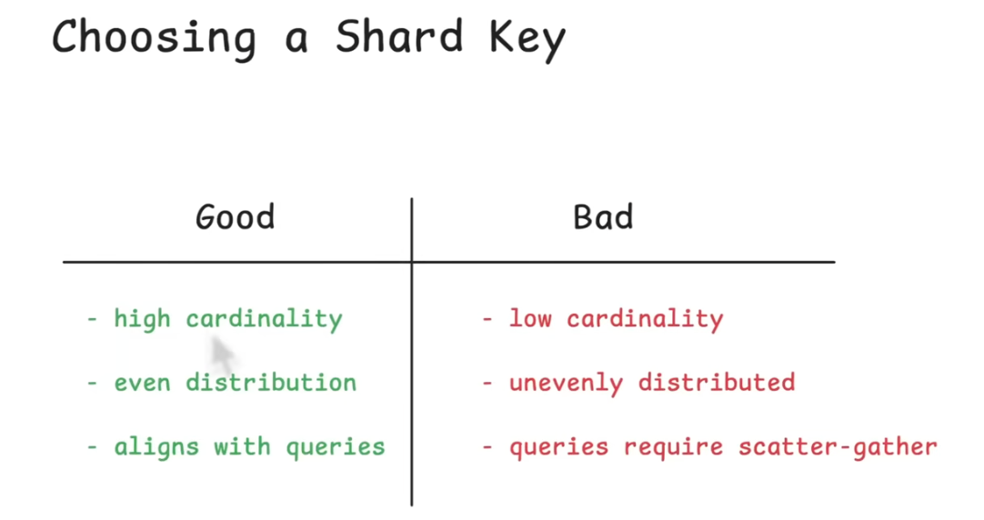

Bad shard key leads to uneven data distribution, hot spots where one shard gets pounded while others sit idle, and queries that have to hit every shard to find what they need. A good shard key distributes data evenly, aligns with your query patterns, and scales as your system grows.

Here's what makes a good shard key:

**High cardinality**: The key should have many unique values. Sharding by a boolean field (true/false) means you can only have two shards max, which defeats the purpose. Sharding by user ID when you have millions of users gives you plenty of room to distribute data.

**Even distribution**: Values should spread evenly across shards. If you shard by country and 90% of your users are in the US, that shard will be massively larger than the others. User ID usually distributes well. Creation timestamps can work if new records don't all pile onto the most recent shard.

**Aligns with queries**: Your most common queries should ideally hit just one shard. If you shard users by user_id, queries like "get user profile" or "get user's orders" hit a single shard. Queries that span all shards become expensive.

For example, some good shard keys would be:

🟢 **user_id** for user-centric app: High cardinality (millions of users), even distribution, and most queries are scoped to a single user anyway ("show me this user's data"). Perfect fit.

🟢 **order_id** for an e-commerce orders table: High cardinality (millions of orders), queries are usually scoped to a specific order ("get order details", "update order status"), and orders distribute evenly over time.

Whereas bad ones could be:

🔴 **is_premium** (boolean): Only two possible values means only two shards. One shard gets all premium users, the other gets free users. If most users are free, that shard is overloaded.

🔴 **created_at** for a growing table: All new writes go to the most recent shard. That shard becomes a hot spot for writes while older shards handle almost no traffic.

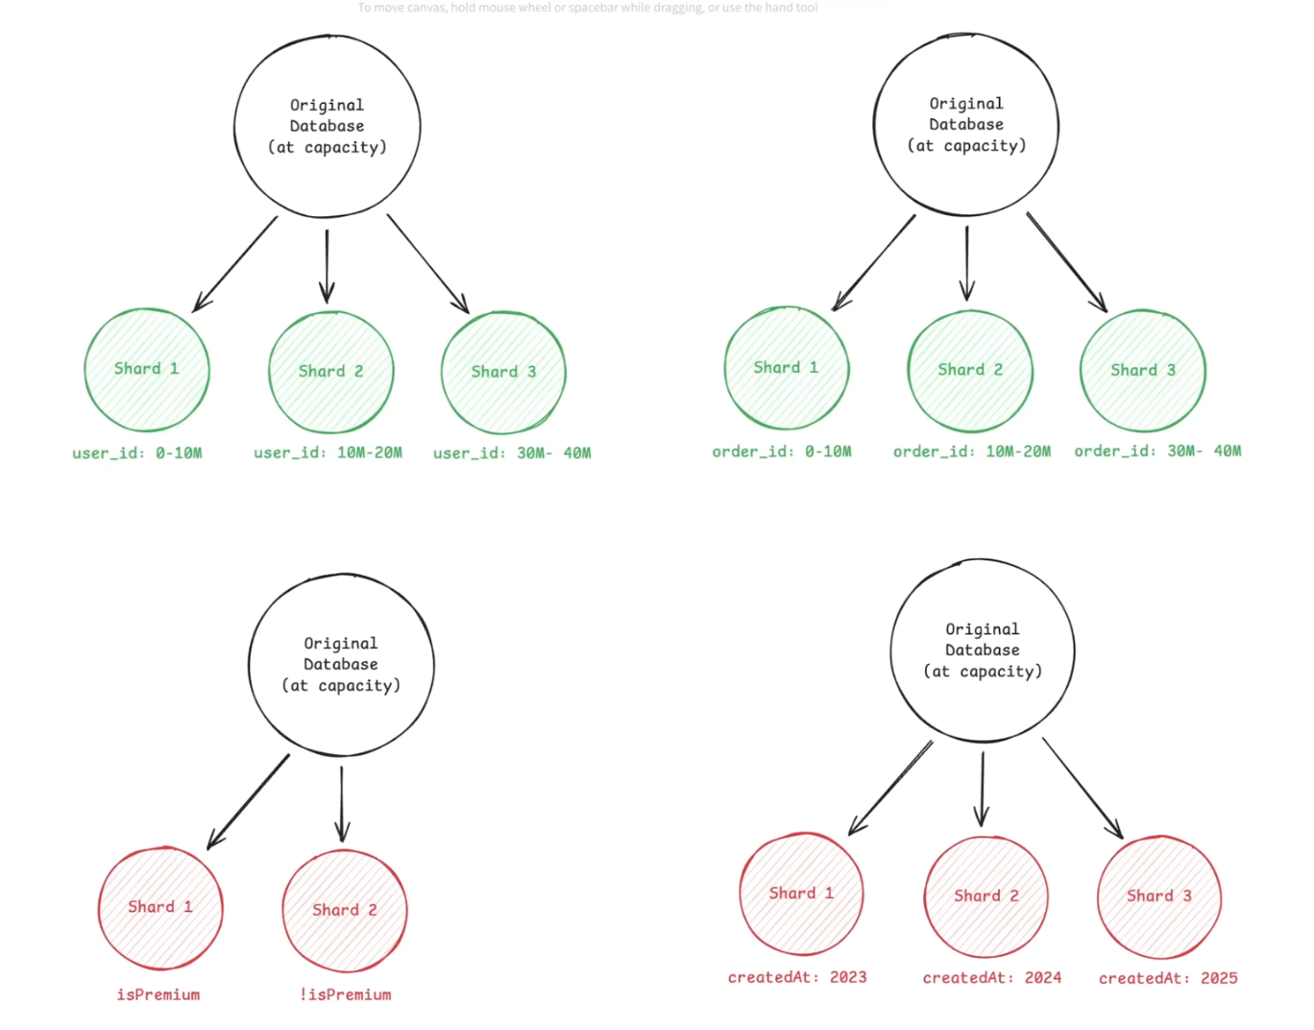

**2. Sharding Strategies**

Once you know your shard key, you need to decide how to distribute that data across shards. There are three main strategies, each with different trade-offs.

**i. Range-Based Sharding**

Range sharding is the most straightforward. It just groups records by a continuous range of values. You pick a shard key like user_id or created_at, then assign value ranges to shards.

eg.

Shard 1 → User IDs 1–1M

Shard 2 → User IDs 1M–2M

Shard 3 → User IDs 2M–3M

The main advantage of range-based sharding is simplicity, support for efficient range scans. If you need all orders between user IDs 500K and 600K, you only hit one shard.

Most real-world access patterns don't distribute evenly across ranges. If you shard orders by created_at, almost all your traffic hits the most recent shard because users care about recent orders. New writes only go to the latest shard. Old shards sit mostly idle.

Range-based sharding works best when different users naturally query different ranges.

**ii. Hash Based Sharding (Default)**

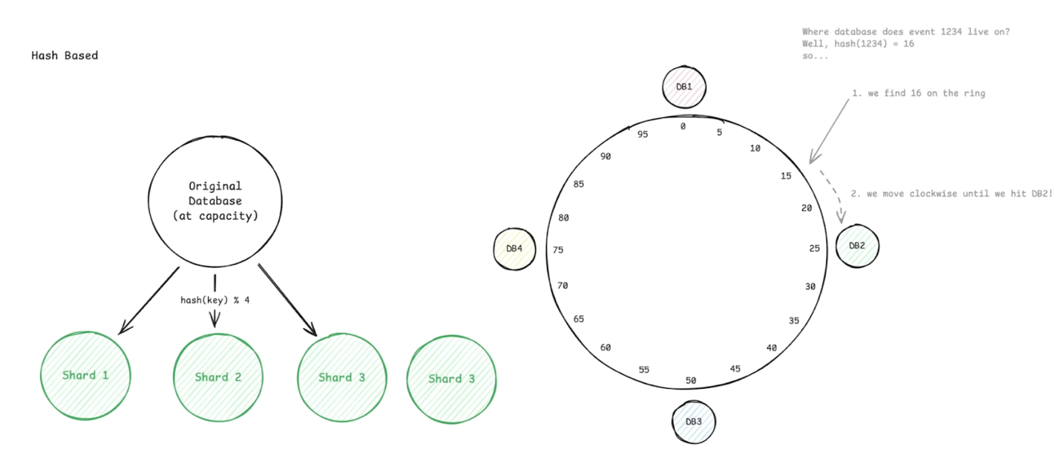

Hash sharding uses a hash function to evenly distribute records across shards.

Instead of assigning ranges, you take a shard key like user_id, hash it, use the result to pick a shard.

For example, if we had 4 shards, we could route users like this:

shard = hash(user_id) % 4

User 42  → hash(42) % 4 = Shard 2

User 99  → hash(99) % 4 = Shard 3

User 123 → hash(123) % 4 = Shard 1

The big advantage of hash-based sharding is even distribution. Since the hash function scrambles the input values, new users get distributed evenly across all shards.

The downside shows up when you need to add or remove shards. If you go from 4 shards to 5, the modulo operation changes from % 4 to % 5, which means almost every record maps to a different shard. You have to move massive amounts of data around.

This is where consistent hashing comes in. Instead of simple modulo, consistent hashing minimizes data movement when you add or remove shards. We cover this in detail in our [consistent hashing page](https://www.hellointerview.com/learn/system-design/core-concepts/consistent-hashing), but the key point is that hash-based sharding works great as long as you have a plan for resharding.

Generally speaking, this is the default and most common sharding strategy. It's also what your interviewer will likely assume you're using unless you explicitly state otherwise.

**iii. Directory-Based Sharding**

Directory sharding uses a lookup table to decide where each record lives. Instead of using a formula, you store shard assignments in a mapping table or service.

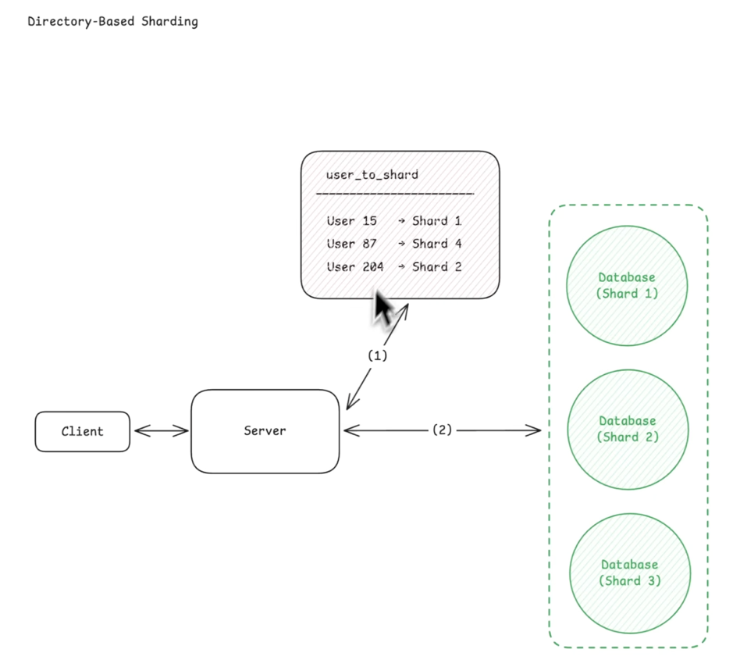

For example:

user_to_shard

----------------------------

User 15   → Shard 1

User 87   → Shard 4

User 204  → Shard 2

The power of directory-based sharding is flexibility. If a particular user generates tons of traffic, you can move them to a dedicated shard. If you need to rebalance load, you just update the mapping table. You can implement complex sharding logic that would be impossible with a simple hash function.

The downside is that every single request requires a lookup. Before you can query user data, you have to ask the directory service which shard that user lives on. This adds latency to every request and makes the directory service a critical dependency. If the directory goes down, your entire system stops working even if all the data shards are healthy.

Directory-based sharding makes sense when you need maximum flexibility and can afford the extra lookup cost. Most systems start with hash-based or range-based sharding and only use a directory if they have specific requirements that demand it.

Realistically, while directory-based sharding is a valid solution for dynamic use cases, it is rarely the answer in a system design interview. It introduces a single point of failure and adds latency to every request, which will prompt your interviewer to ask a number of follow-up questions that could derail the conversation.

**Challenges of Sharding**

**1. Hot Spots and Load Imbalance**

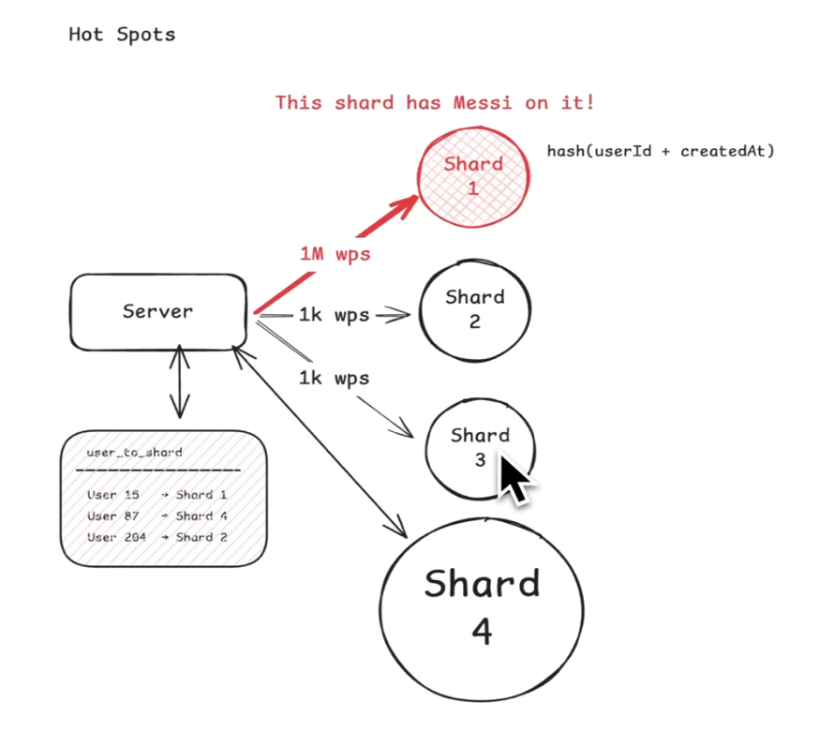

**2. Cross-Shard Operations**

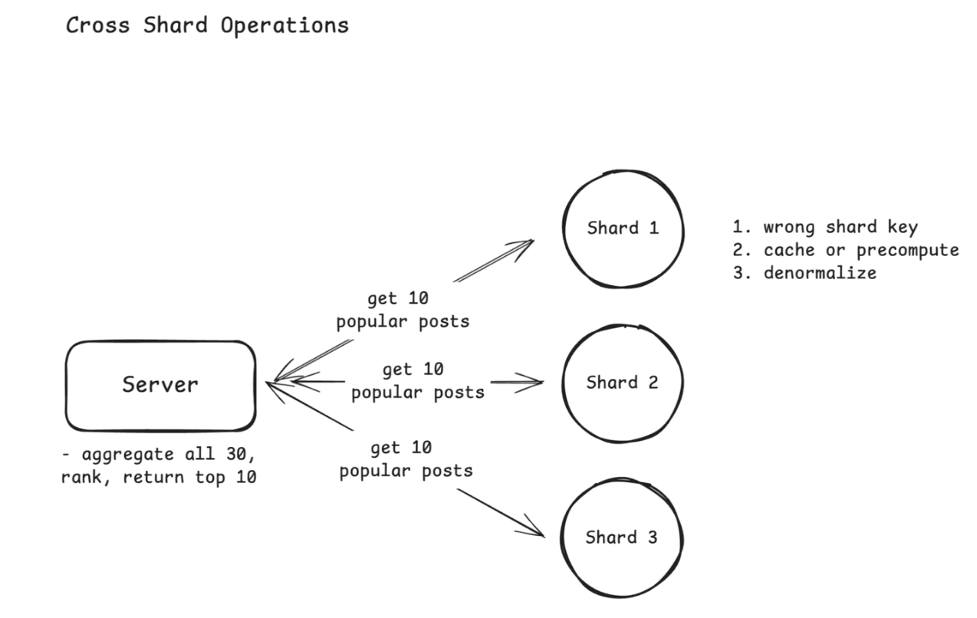

**3. Maintaining Consistency**

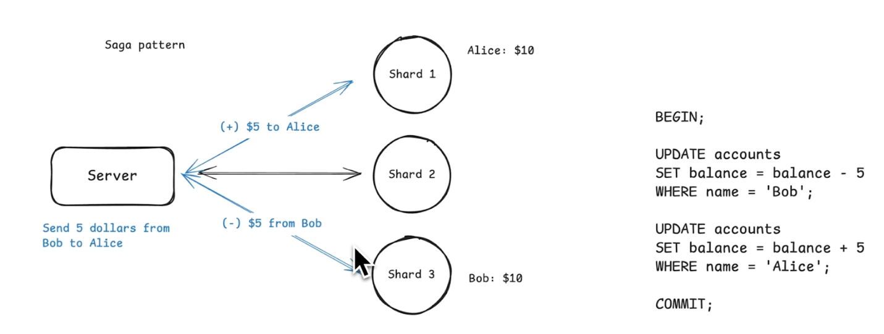

**Sharding in System Design Interviews**

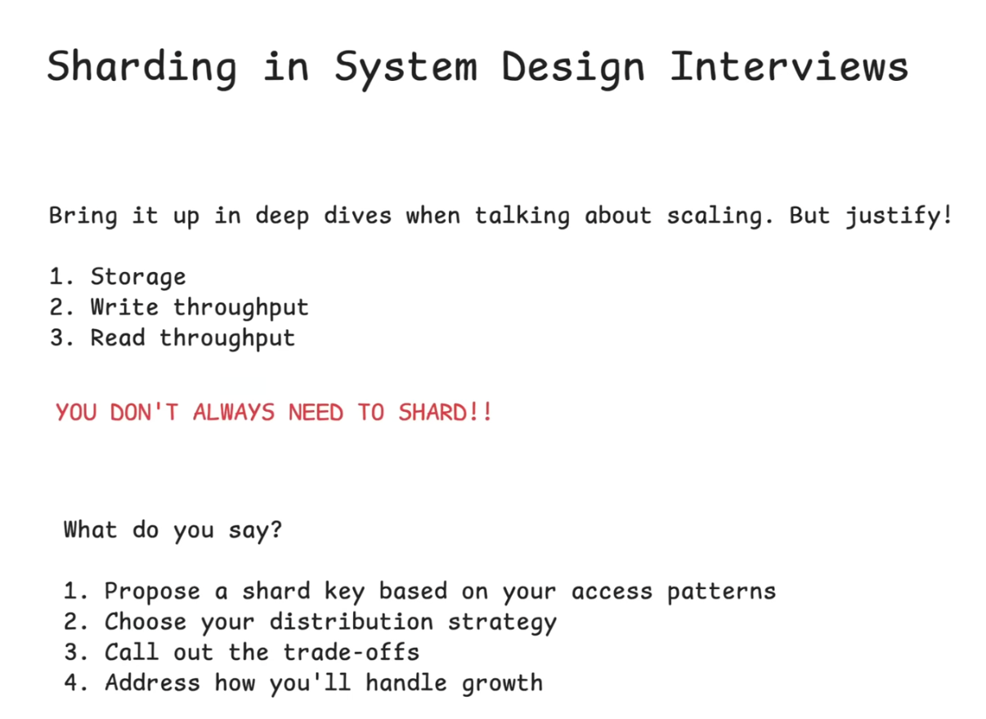

Ok, that is all fine and well, but what should you actually say/do in an interview?

Sharding comes up just about anytime you are discussing scaling. The key is knowing when to bring it up, what to say, and what mistakes to avoid.

**When to Mention Sharding**

Be careful not to make the mistake of prematurely sharding. You need to establish why a single database won't work first.

Bring up sharding when you're discussing capacity planning and hit one of these limits:

* **Storage**: "We have 500M users with 5KB of data each, that's 2.5TB. A single Postgres instance can handle that, but if we grow 10x we'll need to shard."
* **Write throughput**: "We're expecting 50K writes per second during peak. A single database will struggle with that write load, so we should shard."
* **Read throughput**: "Even with read replicas, if we're serving 100M daily active users making multiple queries each, we'll need to distribute the read load across shards."

The formula is simple:

* Identify the bottleneck
* Explain why single database won't scale
* Propose sharding

You can use our [Numbers to Know](https://www.hellointerview.com/learn/system-design/core-concepts/numbers-to-know) in order to get a good sense of when you may hit reasonable limits with a single database.

By far the number one sharding mistake I see in interviews is candidates introducing sharding before they've proven it's necessary. Slow down, do the math, and make sure sharding is actually needed before you start explaining how you'd do it.

What to Say

Here's how to walk through sharding in an interview using a social media app as an example:

**1. Propose a shard key based on your access patterns** "For this social media app, most queries are user-centric. When someone loads their feed, we're querying their posts, their followers, their likes. That's all scoped to a single user. So I'd shard by user_id."

**2. Choose your distribution strategy** "I'd use hash-based sharding with consistent hashing. Hash the user_id to distribute users evenly across shards."

**3. Call out the trade-offs** "The trade-off is that global queries become expensive. If we need 'trending posts across all users' we have to query all shards and aggregate results. We can handle that by caching trending content and pre-computing it with a background job rather than calculating it on every request."

**4. Address how you'll handle growth** "We'll start with 64 shards, which gives us room to grow. Consistent hashing makes it easier to add shards later without resharding all the data. If we need more capacity, we can add shards and only a fraction of the data moves."

Notice how this flows naturally. You're not just listing facts, you're walking through your reasoning and showing you understand the trade-offs.

**Conclusion**

Sharding is what you do when a single database can't handle your scale anymore. You split data across multiple machines to increase storage capacity and throughput.

There are two main decisions that matter: pick a shard key that aligns with your query patterns, and choose a distribution strategy that spreads load evenly. Get these wrong and you'll have hot spots and expensive cross-shard queries.

In interviews, bring up sharding when you've identified a database bottleneck. Walk through your shard key choice, explain the trade-offs, and show you've thought about cross-shard queries and resharding. Most importantly, don't shard too early. A well-tuned single database can get you surprisingly far.